Chapter -1
Operating Systems Overview
Syllabus: UNIT I
Operating Systems Overview: Operating system functions, Operating system structure, operating systems Operations, protection and security, Computing Environments, Open- Source Operating Systems
System Structures: Operating System Services, User and Operating-System Interface, systems calls, Types of System Calls, system programs, operating system structure, operating system debugging, System Boot.
Processes: Process concept, process Scheduling, Operations on processes, Inter process Communication, Examples of IPC systems.
***

An Operating System (OS) is an interface between computer user and computer hardware. An operating system is software which performs all the basic tasks like file management, memory management, process management, handling input and output, and controlling peripheral devices such as disk drives and printers.
Some popular Operating Systems include Linux Operating System, Windows Operating System, VMS, OS/400, AIX, z/OS, etc.
- OS is a resource allocator.
  - Manages all resources
  - Decides between conflicting requests for efficient and fair resource use
- OS is a control program.
  - Controls execution of programs to prevent errors and improper use of the computer
- No universally accepted definition
- “Everything a vendor ships when you order an operating system” is good approximation But varies wildly
- “The one program running at all times on the computer” is the kernel (OS). Everything else is either a system program (ships with the operating system) or an application program.

***

Introduction:
An operating system is a program that manages a computer’s hardware. It also provides a basis for application programs and acts as an intermediary between the computer user and the computer hardware.
Because an operating system is large and complex, it must be created piece by piece. Each of these pieces should be a well-delineated portion of the system, with carefully defined inputs, outputs, and functions.
A computer system can be divided roughly into four components:
- The hardware
- The operating system
- The application programs
- The users
Figure: Abstract view of the components of a computer system.
Hardware - provides basic computing resources
CPU, memory, I/O devices
Operating system - Controls and coordinates use of hardware among various applications and users
Application programs - define the ways in which the system resources are used to solve the computing problems of the users. For example, Word processors, compilers, web browsers, database systems, video games
Users- People, machines, other computers

We can also view a computer system as consisting of hardware, software, and data. The operating system provides the means for proper use of these resources in the operation of the computer system.
An operating system is similar to a government. Like a government, it performs no useful function by itself. It simply provides an environment within which other programs can do useful work.
We can explore operating system from two viewpoints:
- User view
- System view
User view:
The user’s view of the computer varies according to the interface being used. Most computer users sit in front of a PC, consisting of a monitor, keyboard, mouse, and system unit. The considerations here are like Ease of use but user don’t care about Resource utilization.
Systems View:
From the computer’s point of view, the operating system is the program most intimately involved with the hardware.
In this context, we can view an operating system as a resource allocator. A computer system has many resources that may be required to solve a problem: CPU time, memory space, file-storage space, I/O devices, and so on. The operating system acts as the manager of these resources.
***
1.1 Functions of Operating System:
Following are some of important functions of an operating System.
- Memory Management
- Processor Management
- Device Management
- File Management
- Security
- Control over system performance
- Job accounting
- Error detecting aids
- Coordination between other software and users
Memory Management
Memory management refers to management of Primary Memory or Main Memory. Main memory is a large array of words or bytes where each word or byte has its own address.
Main memory provides a fast storage that can be accessed directly by the CPU. For a program to be executed, it must in the main memory. An Operating System does the following activities for
memory management:
- Keeps tracks of primary memory, i.e., what part of it are in use by whom, what part are not in use.
- In multiprogramming, the OS decides which process will get memory when and how much.
- Allocates the memory when a process requests it to do so.
- De-allocates the memory when a process no longer needs it or has been terminated.
Processor Management
In multiprogramming environment, the OS decides which process gets the processor when and for how much time. This function is called process scheduling. An Operating System does the following activities for processor management:
- Keeps tracks of processor and status of process. The program responsible for this task is known as traffic controller.
- Allocates the processor (CPU) to a process.
- De-allocates processor when a process is no longer required.
Device Management
An Operating System manages device communication via their respective drivers. It does the following activities for device management:
- Keeps tracks of all devices. The program responsible for this task is known as the I/O controller.
- Decides which process gets the device when and for how much time.
- Allocates the device in the most efficient way.
- De-allocates devices.
File Management
A file system is normally organized into directories for easy navigation and usage. These directories may contain files and other directions.
An Operating System does the following activities for file management:
- Keeps track of information, location, uses, status etc. The collective facilities are often known as file system.
- Decides who gets the resources.
- Allocates the resources.
- De-allocates the resources.
Other Important Activities
Following are some of the important activities that an Operating System performs:
- Security -- By means of password and similar other techniques, it prevents unauthorized access to programs and data.
- Control over system performance -- Recording delays between request for a service and response from the system.
- Job accounting -- Keeping track of time and resources used by various jobs and users.
- Error detecting aids -- Production of dumps, traces, error messages, and other debugging and error detecting aids.
- Coordination between other software and users -- Coordination and assignment of compilers, interpreters, assemblers and other software to the various users of the computer systems.

***
1.2 Operating system structure
One of the most important aspects of operating systems is the ability to multiprogram. A single program cannot, in general, keep either the CPU or the I/O devices busy at all times. Single users frequently have multiple programs running. Multiprogramming increases CPUutilization by organizing jobs (code and data) so that the CPU always has one to execute.
Figure: Memory layout for a multiprogramming system.
The idea is as follows: The operating system keeps several jobs in memory simultaneously (as in above figure). Since, in general, main memory is too small to accommodate all jobs, the jobs are kept initially on the disk in the job pool. This pool consists of all processes residing on disk awaiting allocation of main memory.
The set of jobs in memory can be a subset of the jobs kept in the job pool. The operating system picks and begins to execute one of the jobs in memory. Eventually, the job may have to wait for some task, such as an I/O operation, to complete. In a non-multiprogrammed system, the CPU would sit idle. In a multiprogrammed system, the operating system simply switches to, and executes, another job. When that job needs to wait, the CPU switches to another job, and so on. Eventually, the first job finishes waiting and gets the CPU back. As long as at least one job needs to execute, the CPU is never idle.
Multiprogrammed systems provide an environment in which the various system resources (for example, CPU, memory, and peripheral devices) are utilized effectively, but they do not provide for user interaction with the computer system. Time sharing (or multitasking) is a logical extension of multiprogramming. In time-sharing systems, the CPU executes multiple jobs by switching among them, but the switches occur so frequently that the users can interact with each program while it is running.
Time sharing requires an interactive computer system, which provides direct communication between the user and the system. The user gives instructions to the operating system or to a program directly, using a input device such as a keyboard, mouse, touch pad, or touch screen, and waits for immediate results on an output device. Accordingly, the response time should be short—typically less than one second.
A time-shared operating system allows many users to share the computer simultaneously. Since each action or command in a time-shared system tends to be short, only a little CPU time is needed for each user. As the system switches rapidly from one user to the next, each user is given the impression that the entire computer system is dedicated to his use, even though it is being shared among many users.
A program loaded into memory and executing is called a process. When a process executes, it typically executes for only a short time before it either finishes or needs to perform I/O. I/O may be interactive; that is, output goes to a display for the user, and input comes from a user keyboard, mouse, or other device. Since interactive I/O typically runs at “people speeds,” it may take a long time to complete. Input, for example, may be bounded by the user’s typing speed; seven characters per second is fast for people but incredibly slow for computers. Rather than let the CPU sit idle as this interactive input takes place, the operating system will rapidly switch the CPU to the program of some other user.
Time sharing and multiprogramming require that several jobs be kept simultaneously in memory. If several jobs are ready to be brought into memory, and if there is not enough room for all of them, then the system must choose among them. Making this decision involves job scheduling. When the operating system selects a job from the job pool, it loads that job into memory for execution. Having several programs in memory at the same time requires some form of memory management. In addition, if several jobs are ready to run at the same time, the system must choose which job will run first. Making this decision is CPU scheduling. Finally, running multiple jobs concurrently requires that their ability to affect one another be limited in all phases of the operating system, including process scheduling, disk storage, and memory management.
In a time-sharing system, the operating system must ensure reasonable response time. This goal is sometimes accomplished through swapping, whereby processes are swapped in and out of main memory to the disk. Amore common method for ensuring reasonable response time is virtual memory, a technique that allows the execution of a process that is not completely inmemory. The main advantage of the virtual-memory scheme is that it enables users to run programs that are larger than actual physical memory. Further, it abstracts main memory into a large, uniform array of storage, separating logical memory as viewed by the user from physical memory. This arrangement frees programmers from concern over memory-storage limitations.
***

1.3 Operating-System Operations
The modern operating systems are interrupt driven.If there are no processes to execute, no I/O devices to service, and no users to whom to respond, an operating system will sit quietly, waiting for something to happen.
Events are almost always signalled by the occurrence of an interrupt or a trap. A trap (or an exception) is a software-generated interrupt caused either by an error (for example, division by zero or invalid memory access) or by a specific request from a user program that an operating-system service be performed.
The interrupt-driven nature of an operating system defines that system’s general structure. For each type of interrupt, separate segments of code in the operating system determine what action should be taken. An interrupt service routine is provided to deal with the interrupt.
Since the operating system and the users share the hardware and software resources of the computer system, we need to make sure that an error in a user program could cause problems only for the one program running. With sharing, many processes could be adversely affected by a bug in one program. For example, if a process gets stuck in an infinite loop, this loop could prevent the correct operation of many other processes. More subtle errors can occur in a multiprogramming system, where one erroneous program might modify another program, the data of another program, or even the operating system itself.
Without protection against these sorts of errors, either the computer must execute only one process at a time or all output must be suspect. A properly designed operating system must ensure that an incorrect (or malicious) program cannot cause other programs to execute incorrectly.
Dual-Mode:
To ensure the proper execution of the operating system we have to distinguish between the execution of operating-system code and user defined code.
There are two separate modes of operation:
- User mode
- Kernel mode(also called as supervisormode, systemmode, or privilegedmode)
A bit, called the mode bit, is added to the hardware of the computer to indicate the current mode: kernel (0) or user (1). With the mode bit, we can distinguish between a task that is executed on behalf of the operating system and one that is executed on behalf of the user.
When the computer system is executing on behalf of a user application, the system is in user mode.
However, when a user application requests a service from the operating system (via a system call), the system must transition from user to kernel mode to fulfil the request.
Figure: Transition from user to kernel mode.
At system boot time, the hardware starts in kernel mode. The operating system is then loaded and starts user applications in user mode.
Timer:
We must ensure that the operating system maintains control over the CPU. We cannot allow a user program to get stuck in an infinite loop or to fail to call system services and never return control to the operating system.
To accomplish this goal, A timer is needed. A timer can be set to interrupt the computer after a specified period. The period may be
- fixed (for example, 1/60 second) or
- Variable (for example, from 1 millisecond to 1 second).
A variable timer is generally implemented by a fixed-rate clock and a counter. The operating system sets the counter. Every time the clock ticks, the counter is decremented. When the counter reaches 0, an interrupt occurs. For instance, a 10-bit counter with a 1-millisecond clock allows interrupts at intervals from 1 millisecond to 1,024 milliseconds, in steps of 1 millisecond.
***
1.4 protection and security
Protection – any mechanism for controlling access of processes or users to resources defined by the OS
Security – defence of the system against internal and external attacks
Huge range including denial-of-service, worms, viruses, identity theft, theft of service.
Systems generally first distinguish among users, to determine who can do what
- User identities (user IDs, security IDs) include name and associated number, one per user
- User ID then associated with all files, processes of that user to determine access control
- Group identifier (group ID) allows set of users to be defined and controls managed, then also associated with each process, file
- Privilege escalation allows user to change to effective ID with more rights

If a computer system has multiple users and allows the concurrent execution of multiple processes, then access to data must be regulated. For that purpose, mechanisms ensure that files, memory segments, CPU, and other resources can be operated on by only those processes that have gained proper authorization from the operating system. For example, memory-addressing hardware ensures that a process can execute only within its own address space. The timer ensures that no process can gain control of the CPU without eventually relinquishing control. Device-control registers are not accessible to users, so the integrity of the various peripheral devices is protected.
Protection, then, is any mechanism for controlling the access of processes or users to the resources defined by a computer system. This mechanism must provide means to specify the controls to be imposed and to enforce the controls. Protection can improve reliability by detecting latent errors at the interfaces between component subsystems. Early detection of interface errors can often prevent contamination of a healthy subsystem by another subsystem that is malfunctioning. Furthermore, an unprotected resource cannot defend against use (or misuse) by an unauthorized or incompetent user.
A system can have adequate protection but still be prone to failure and allow inappropriate access. Consider a user whose authentication information (her means of identifying herself to the system) is stolen. Her data could be copied or deleted, even though file and memory protection are working. It is the job of security to defend a system from external and internal attacks. Such attacks spread across a huge range and include viruses and worms, denial-of service attacks (which use all of a system’s resources and so keep legitimate users out of the system), identity theft, and theft of service (unauthorized use of a system). Prevention of some of these attacks is considered an operating-system function on some systems, while other systems leave it to policy or additional software. Due to the alarming rise in security incidents, operating-system security features represent a fast-growing area of research and implementation.
Protection and security require the system to be able to distinguish among all its users. Most operating systems maintain a list of user names and associated user identifiers (user IDs). In Windows parlance, this is a security ID (SID). These numerical IDs are unique, one per user. When a user logs in to the system, the authentication stage determines the appropriate user ID for the user. That user ID is associated with all of the user’s processes and threads. When an ID needs to be readable by a user, it is translated back to the user name via the user name list.
In some circumstances, we wish to distinguish among sets of users rather than individual users. For example, the owner of a file on a UNIX system may be allowed to issue all operations on that file, whereas a selected set of users may be allowed only to read the file. To accomplish this, we need to define a group name and the set of users belonging to that group. Group functionality can be implemented as a system-wide list of group names and group identifiers. A user can be in one or more groups, depending on operating-system design decisions. The user’s group IDs are also included in every associated process and thread.
In the course of normal system use, the user ID and group ID for a user are sufficient. However, a user sometimes needs to escalate privileges to gain extra permissions for an activity. The user may need access to a device that is restricted, for example. Operating systems provide various methods to allow privilege escalation. On UNIX, for instance, the set uid attribute on a program causes that program to run with the user ID of the owner of the file, rather than the current user’s ID. The process runs with this effective UID until it turns off the extra privileges or terminates.
***
1.5 Computing Environments
Operating systems are used in a variety of computing environments. They are:
- Traditional Computing
  - Blurring over time
  - Office environment
    - PCs connected to a network, terminals attached to mainframe or minicomputers providing batch and timesharing
    - Now portals allowing networked and remote systems access to same resources
  - Home networks
    - Used to be single system, then modems
    - Now firewalled, networked

- Client–Server Computing
  - Dumb terminals supplanted by smart PCs
  - Many systems now servers, responding to requests generated by clients
    - Computer-server provides an interface to client to request services (i.e., database)
    - File-server provides interface for clients to store and retrieve files

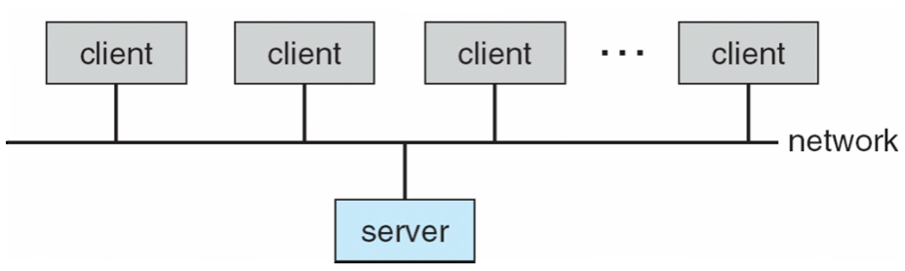

- Peer-to-Peer Computing
- Another model of distributed system
- P2P does not distinguish clients and servers
    - Instead all nodes are considered peers
    - May each act as client, server or both
    - Node must join P2P network
      - Registers its service with central lookup service on network, or
      - Broadcast request for service and respond to requests for service via discovery protocol
    - Examples include Napster and Gnutella
- Web based computing
  - Web has become ubiquitous
  - PCs most prevalent devices
  - More devices becoming networked to allow web access
  - New category of devices to manage web traffic among similar servers: load balancers
  - Use of operating systems like Windows 95, client-side, have evolved into Linux and Windows XP, which can be clients and servers

Others Environments:
- Virtualization
- Cloud Computing
- Real-Time Embedded Systems
- Mobile Computing
- Distributed Systems
***
1.6 Open- Source Operating Systems
Open-source operating systems are those available in source-code format rather than as compiled binary code.
- Linux is the most famous open source operating system
- While Microsoft Windows is a well-known example for closed source approach.
- Apple’s Mac OS X and iOS operating systems comprise a hybrid approach. They contain an open-source kernel named Darwin yet include proprietary, closed-source components as well.
Starting with the source code allows the programmer to produce binary code that can be executed on a system. Doing the opposite—reverse engineering the source code from the binaries—is quite a lot of work and useful items such as comments are never recovered. Learning operating systems by examining the source code has other benefits as well.
There are many benefits to open-source operating systems, including a community of interested (and usually unpaid) programmers who contribute to the code by helping to debug it, analyze it, provide support, and suggest changes.
Arguably, open-source code is more secure than closed-source code because many more eyes are viewing the code. Certainly, open-source code has bugs, but open-source advocates argue that bugs tend to be found and fixed faster owing to the number of people using and viewing the code.
History
In the early days of modern computing (that is, the 1950s), a great deal of software was available in open-source format. The original hackers (computer enthusiasts) at MIT’s Tech Model Railroad Club left their programs in drawers for others to work on. “Homebrew” user groups exchanged code during their meetings.
Later, company-specific user groups, such as Digital Equipment Corporation’s DEC, accepted contributions of source-code programs, collected them onto tapes, and distributed the tapes to interested members. Computer and software companies eventually sought to limit the use of their software to authorized computers and paying customers. Releasing only the binary files compiled from the source code, rather than the source code itself, helped them to achieve this goal, as well as protecting their code and their ideas from their competitors. Another issue involved copyrighted material.
Operating systems and other programs can limit the ability to play back movies and music or display electronic books to authorized computers. Such copy protection or digital rights management (DRM) would not be effective if the source code that implemented these limits were published. Laws in many countries, including the U.S. Digital Millennium Copyright Act (DMCA), make it illegal to reverse-engineer DRM code or otherwise try to circumvent copy protection.
Richard Stallman in 1983 started the GNU project to create a free, open-source, UNIX compatible operating system. In 1985, he published the GNU Manifesto, whichargues that all software should be free and open-sourced. He also formed the Free Software Foundation (FSF) with the goal of encouraging the free exchange of software source code and the free use of that software. Rather than copyright its software, the FSF “copylefts” the software to encourage sharing and improvement.
The GNU General Public License (GPL) codifies copylefting and is a common license under which free software is released. Fundamentally, GPL requires that the source code be distributed with any binaries and that any changes made to the source code be released under the same GPL license.

Linux
As an example of an open-source operating system, consider GNU/Linux. The GNU project produced many UNIX-compatible tools, including compilers, editors, and utilities, but never released a kernel.
In 1991, a student in Finland, Linus Torvalds, released a rudimentary UNIX-like kernel using the GNU compilers and tools and invited contributions worldwide. The advent of the Internet meant that anyone interested could download the source code, modify it, and submit changes to Torvalds. Releasing updates once a week allowed this so-called Linux operating system to grow rapidly, enhanced byseveral thousand programmers.
The resulting GNU/Linux operating system has spawned hundreds of unique distributions, or custom builds, of the system. Major distributions include RedHat, SUSE, Fedora, Debian, Slackware, and Ubuntu. Distributions vary in function, utility, installed applications, hardware support, user interface, and purpose. For example, RedHat Enterprise Linux is geared to large commercial use.
PCLinuxOS is a LiveCD—an operating system that can be booted and run from a CD-ROM without being installed on a system’s hard disk.
One variant of PCLinuxOS—called “PCLinuxOS Supergamer DVD”—is a LiveDVD that includes graphics drivers and games. A gamer can run it on any compatible system simply by booting from the DVD. When the gamer is finished, a reboot of the system resets it to its installed operating system.
You can run Linux on a Windows system using the following simple, free approach:
1. Download the free “VMware Player” tool from http://www.vmware.com/download/player/
and install it on your system.
2. Choose a Linux version from among the hundreds of “appliances,” or virtual machine images, available from VMware at http://www.vmware.com/appliances/
BSD UNIX
BSD UNIX has a longer and more complicated history than Linux. It started in 1978 as a derivative of AT&T’s UNIX. Releases from the University of California at Berkeley (UCB) came in source and binary form, but they were not open source because a license from AT&T was required. BSD UNIX’s development was slowed by a lawsuit by AT&T, but eventually a fully functional, open-source version, 4.4BSD-lite, was released in 1994.
Just as with Linux, there are many distributions of BSD UNIX, including FreeBSD, NetBSD, OpenBSD, and DragonflyBSD. To explore the source code of FreeBSD, simply download the virtual machine image of the version of interest and boot it within VMware, as described above for Linux. The source code comes with the distribution and is stored in /usr/src/. The kernel source code is in /usr/src/sys. For example, to examine the virtual memory implementation code in the FreeBSD kernel, see the files in /usr/src/sys/vm.
Darwin, the core kernel component of Mac OS X, is based on BSD UNIX and is open-sourced as well. That source code is available from http://www.opensource.apple.com/. Every Mac OS X release has its opensource components posted at that site. The name of the package that contains the kernel begins with “xnu.”
Solaris
Solaris is the commercial UNIX-based operating system of Sun Microsystems. Originally, Sun’s SunOS operating system was based on BSD UNIX. Sunmoved to AT&T’s System V UNIX as its base in 1991. In 2005, Sun open-sourced most of the Solaris code as the OpenSolaris project. The purchase of Sun by Oracle in 2009, however, left the state of this project unclear. The source code as it was in 2005 is still available via a source code browser and for download at http://src.opensolaris.org/source.
Several groups interested in using OpenSolaris have started from that base and expanded its features. Their working set is Project Illumos, which has expanded from the OpenSolaris base to include more features and to be the basis for several products. Illumos is available at http://wiki.illumos.org.
***
References:Abraham Silberschatz, Greg Gagne, and Peter Baer Galvin, "Operating System Concepts, Ninth Edition "

SYSTEM STRUCTURES
System Structures: Operating System Services, User and Operating-System Interface, systems calls, Types of System Calls, system programs, operating system structure, operating system debugging, System Boot.
***
Operating System Services:
An operating system provides an environment for the execution of programs. It provides certain services to programs and to the users of those programs. The specific services provided, of course, differ from one operating system to another, but we can identify common classes. These operating system services are provided for the convenience of the programmer, to make the programming task easier.Following Figure shows one view of the various operating-system services and how they interrelate.
Figure: A view of operating system services
One set of operating system services provides functions that are helpful to the user.
- User interface
- Program execution
- I/O operations
- File-system manipulation
- Communications
- Error detection
Another set of operating system functions exists not for helping the userbut rather for ensuring the efficient operation of the system itself. Systems withmultiple users can gain efficiency by sharing the computer resources amongthe users.

- Resource allocation
- Accounting
- Protection and security
User interface: Almost all operating systems have a user interface (UI). This interface can take several forms. One is a command-line interface (CLI), which uses text commands and a method for entering them (say, a keyboard for typing in commands in a specific format with specific options). Another is a batch interface, in which commands and directives to control those commands are entered into files, and those files are executed. Most commonly, a graphical user interface (GUI) is used. Here, the interface is a window system with a pointing device to direct I/O, choose from menus, and make selections and a keyboard to enter text. Some systems provide two or all three of these variations.
Program execution: The system must be able to load a program into memory and to run that program. The program must be able to end its execution, either normally or abnormally (indicating error).
I/O operations: A running program may require I/O, which may involve a file or an I/O device. For specific devices, special functions may be desired (such as recording to a CD or DVD drive or blanking a display screen). For efficiency and protection, users usually cannot control I/O devices directly. Therefore, the operating system must provide a means to do I/O.
File-system manipulation: The file system is of particular interest. Obviously, programs need to read and write files and directories. They also need to create and delete them by name, search for a given file, and list file information. Finally, some operating systems include permissions management to allow or deny access to files or directories based on file ownership. Many operating systems provide a variety of file systems, sometimes to allow personal choice and sometimes to provide specific features or performance characteristics.
Communications: There are many circumstances in which one process needs to exchange information with another process. Such communication may occur between processes that are executing on the same computer or between processes that are executing on different computer systems tied together by a computer network. Communications may be implemented via shared memory, in which two or more processes read and write to a shared section of memory, or message passing, in which packets of information in predefined formats are moved between processes by the operating system.
Error detection: The operating system needs to be detecting and correcting errors constantly. Errors may occur in the CPU and memory hardware (such as a memory error or a power failure), in I/O devices (such as a parity error on disk, a connection failure on a network, or lack of paper in the printer), and in the user program (such as an arithmetic overflow, an attempt to access an illegal memory location, or a too-great use of CPU time). For each type of error, the operating system should take the appropriate action to ensure correct and consistent computing. Sometimes, it has no choice but to halt the system. At other times, it might terminate an error-causing process or return an error code to a process for the process to detect and possibly correct.
Resource allocation: When there are multiple users or multiple jobs running at the same time, resources must be allocated to each of them. The operating system manages many different types of resources. Some (such as CPU cycles, main memory, and file storage) may have special allocation code, whereas others (such as I/O devices) may have much more general request and release code. For instance, in determining how best to use the CPU, operating systems have CPU-scheduling routines that take into account the speed of the CPU, the jobs that must be executed, the number of registers available, and other factors. There may also be routines to allocate printers, USB storage drives, and other peripheral devices.
Accounting: We want to keep track of which users use how much and what kinds of computer resources. This record keeping may be used for accounting (so that users can be billed) or simply for accumulating usage statistics. Usage statistics may be a valuable tool for researchers who wish to reconfigure the system to improve computing services.
Protection and security: The owners of information stored in a multiuser or networked computer system may want to control use of that information. When several separate processes execute concurrently, it should not be possible for one process to interfere with the others or with the operating system itself. Protection involves ensuring that all access to system resources is controlled. Security of the system from outsiders is also important. Such security starts with requiring each user to authenticate himself or herself to the system, usually by means of a password, to gain access to system resources. It extends to defending external I/O devices, including network adapters, from invalid access attempts and to recording all such connections for detection of break-ins. If a system is to be protected and secure, precautions must be instituted throughout it. A chain is only as strong as its weakest link.
***
User and Operating-System Interface:
There are several ways for users to interface with the operating system. The two fundamental approaches are
- The command-line interface or command interpreter, that allows users to directly enter commands to be performed by the operating system.
- The graphical user interface, that allows users to interface with the operating system via a graphical user interface, or GUI.
Command Interpreters:
Some operating systems include the command interpreter in the kernel. Others, such asWindows and UNIX, treat the command interpreter as a special program that is running when a job is initiated or when a user first logs on (on interactive systems). On systems with multiple command interpreters to choose from, the interpreters are known as shells. For example, on UNIX and Linux systems, a user may choose among several different shells, including the Bourne shell, C shell, Bourne-Again shell, Korn shell, and others. Third-party shells and free user-written shells are also available. Most shells provide similar functionality, and a user’s choice of which shell to use is generally based on personal preference. Following Figure shows the Bourne shell command interpreter being used on Solaris 10.
Figure: The Bourne shell command interpreter in Solrais 10.
The main function of the command interpreter is to get and execute the next user-specified command. Manyof the commands given at this level manipulate files: create, delete, list, print, copy, execute, and so on. The MS-DOS and UNIX shells operate in this way. These commands can be implemented in two general ways.
In one approach, the command interpreter itself contains the code to execute the command. For example, a command to delete a file may cause the command interpreter to jump to a section of its code that sets up the parameters and makes the appropriate system call. In this case, the number of commands that can be given determines the size of the command interpreter, since each command requires its own implementing code.
An alternative approach—used by UNIX, among other operating systems —implements most commands through system programs. In this case, the command interpreter does not understand the command in any way; it merely uses the command to identify a file to be loaded into memory and executed. Thus, the UNIX command to delete a file
rm file.txt
would search for a file called rm, load the file intomemory, and execute it with the parameter file.txt. The function associatedwith the rm command would be defined completely by the code in the file rm. In thisway, programmers can add new commands to the system easily by creating new files with the proper names. The command-interpreter program, which can be small, does not have to be changed for new commands to be added.
Graphical User Interfaces:
A second strategy for interfacingwith the operating systemis through a userfriendlygraphical user interface, or GUI. Here, rather than entering commandsdirectly via a command-line interface, users employ a mouse-based window and- menu system characterized by a desktop metaphor. The user moves the mouse to position its pointer on images, or icons, on the screen (the desktop)that represent programs, files, directories, and system functions. Dependingon the mouse pointer’s location, clicking a button on the mouse can invoke aprogram, select a file or directory—known as a folder—or pull down amenuthat contains commands.
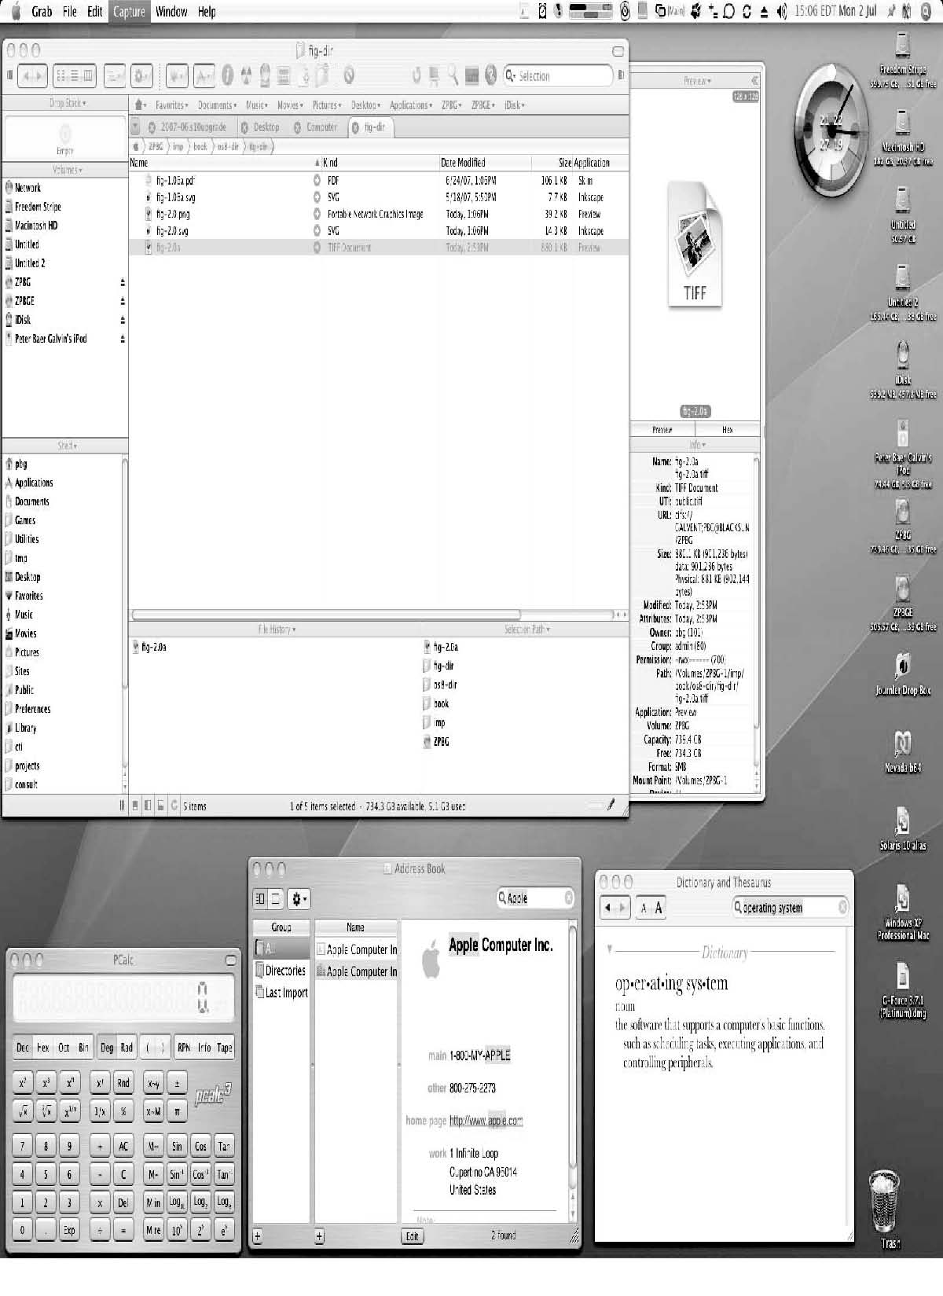
Figure: The Mac OS X GUI.
Many systems now include both CLI and GUI interfaces
- Microsoft Windows is GUI with CLI “command” shell
- Apple Mac OS X as “Aqua” GUI interface with UNIX kernel underneath and shells available
- Solaris is CLI with optional GUI interfaces (Java Desktop, KDE)
***
System Calls:
- System calls provide an interface to the services made available by an operating system.
- Typically written in a high-level language (C or C++)
- Mostly accessed by programs via a high-level Application Program Interface (API) rather than direct system call use
- Three most common APIs are Win32 API for Windows, POSIX API for POSIX-based systems (including virtually all versions of UNIX, Linux, and Mac OS X), and Java API for the Java virtual machine (JVM)
let’s first use an example to illustrate how system calls are used: writing a simple program to read data from one file and copy them to another file. The first input that the program will need is the names of the two files: the input file and the output file. These names can be specified in many ways, depending on the operating-system design. One approach is for the program to ask the user for the names. In an interactive system, this approach will require a sequence of system calls, first to write a prompting message on the screen and then to read from the keyboard the characters that define the two files. On mouse-based and icon-based systems, a menu of file names is usually displayed in a window. The user can then use the mouse to select the source name, and a window can be opened for the destination name to be specified. This sequence requires many I/O system calls.
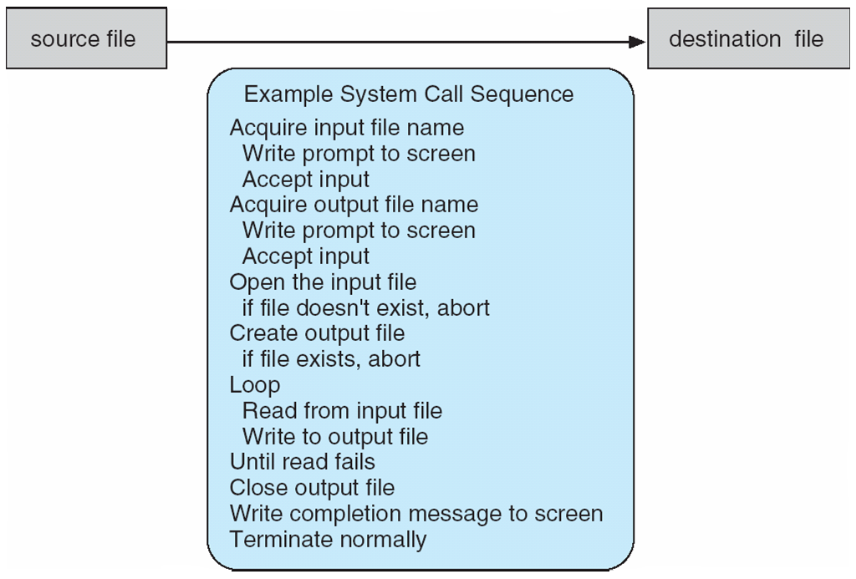
Once the two file names have been obtained, the program must open the input file and create the output file. Each of these operations requires another system call. Possible error conditions for each operation can require additional system calls. When the program tries to open the input file, for example, it may find that there is no file of that name or that the file is protected against access. In these cases, the program should print a message on the console (another sequence of system calls) and then terminate abnormally (another system call). If the input file exists, then we must create a new output file.We may find that there is already an output file with the same name. This situation may cause the program to abort (a system call), or we may delete the existing file (another system call) and create a new one (yet another system call). Another option, in an interactive system, is to ask the user (via a sequence of system calls to output the prompting message and to read the response from the terminal) whether to replace the existing file or to abort the program.
When both files are set up, we enter a loop that reads from the input file (a system call) and writes to the output file (another system call). Each read and write must return status information regarding various possible error conditions. On input, the program may find that the end of the file has been reached or that there was a hardware failure in the read (such as a parity error). The write operation may encounter various errors, depending on the output device (for example, no more disk space).then invokes the intended system call in the operating-system kernel and returns the status of the system call and any return values.

Figure: The handling of a user application invoking the open () system call.

The caller need know nothing about how the system call is implemented or what it does during execution. Rather, the caller need only obey the API and understand what the operating system will do as a result of the execution of that system call. Thus, most of the details of the operating-system interface are hidden from the programmer by the API and are managed by the run-time support library. The relationship between an API, the system-call interface, and the operating system is shown in Figure, which illustrates how the operating system handles a user application invoking the open() system call.
C program invoking printf() library call, which calls write() system call

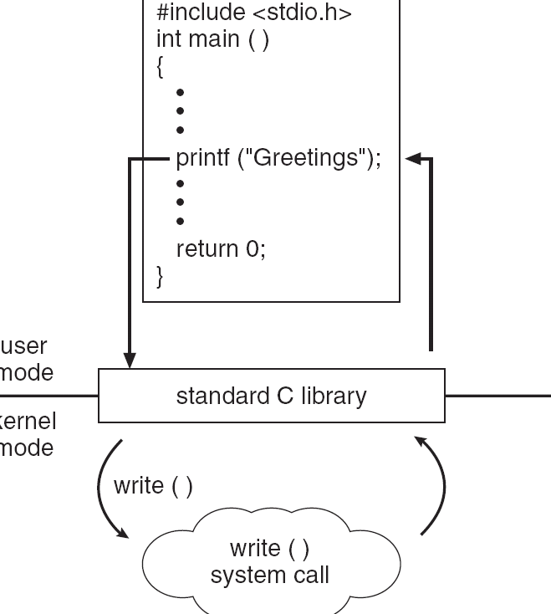

System Call Parameter Passing:
- Often, more information is required than simply identity of desired system call
  - Exact type and amount of information vary according to OS and call
- Three general methods used to pass parameters to the OS
  - Simplest: pass the parameters in registers
    - In some cases, may be more parameters than registers
  - Parameters stored in a block, or table, in memory, and address of block passed as a parameter in a register
    - This approach taken by Linux and Solaris
  - Parameters placed, or pushed, onto the stack by the program and popped off the stack by the operating system
  - Block and stack methods do not limit the number or length of parameters being passed
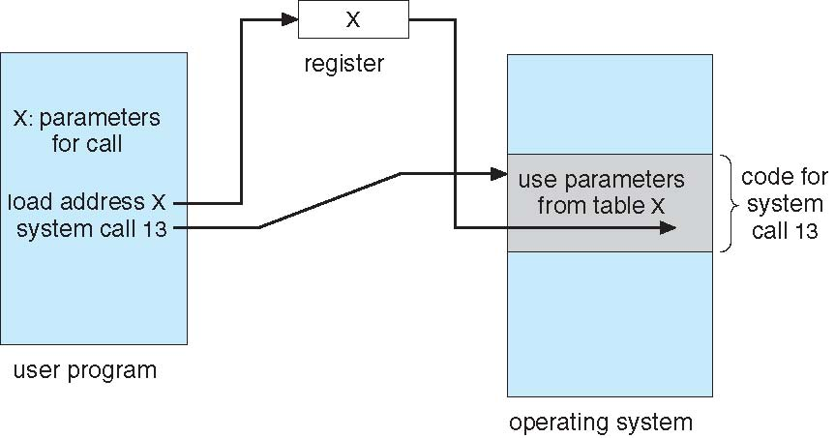

***

Types of System Calls:
System calls can be grouped roughly into six major categories:
- Process control
- File manipulation
- Device manipulation
- Information maintenance,
- Communications
- Protection

- Process control
- end, abort
- load, execute
- create process, terminate process
- get process attributes, set process attributes
- wait for time
- wait event, signal event
- allocate and free memory
- File management
- create file, delete file
- open, close
- read, write, reposition
- get file attributes, set file attributes
- Device management
- request device, release device
- read, write, reposition
- get device attributes, set device attributes
- logically attach or detach devices
- Information maintenance
- get time or date, set time or date
- get system data, set system data
- get process, file, or device attributes
- set process, file, or device attributes

- Communications
- create, delete communication connection
- send, receive messages
- transfer status information
- attach or detach remote devices
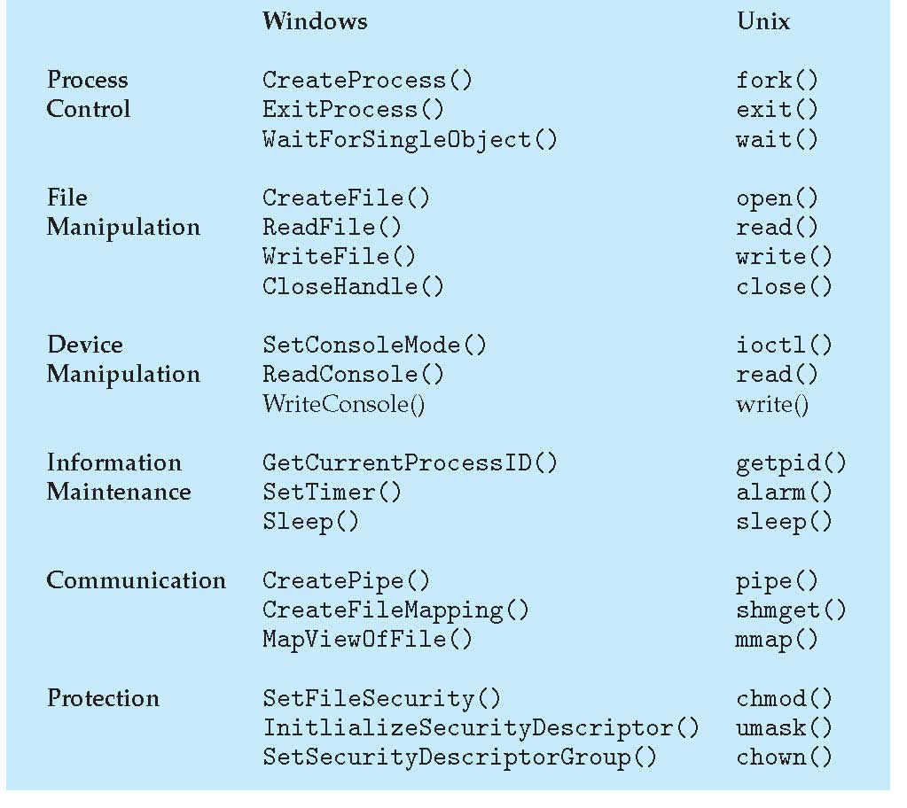
***
System Programs
Another aspect of a modern system is its collection of system programs. Generally, At the lowest level is hardware. Next is the operating system, then the system programs, and finally the application programs. System programs, also known as system utilities, provide a convenient environment for program development and execution. Some of them are simply user interfaces to system calls. Others are considerably more complex. They can be divided into these categories:
- File management
- Status information
- File modification
- Programming-language support
- Communications
- Background services
File management: These programs create, delete, copy, rename, print, dump, list, and generally manipulate files and directories.
Status information: Some programs simply ask the system for the date, time, amount of available memory or disk space, number of users, or similar status information. Others are more complex, providing detailed performance, logging, and debugging information. Typically, these programs format and print the output to the terminal or other output devices or files or display it in a window of the GUI. Some systems also support a registry, which is used to store and retrieve configuration information.
File modification: Several text editors may be available to create and modify the content of files stored on disk or other storage devices. There may also be special commands to search contents of files or perform transformations of the text.
Programming-language support: Compilers, assemblers, debuggers, and interpreters for common programming languages (such as C, C++, Java, and PERL) are often provided with the operating system or available as a separate download.
Program loading and execution: Once a program is assembled or compiled, it must be loaded into memory to be executed. The system may provide absolute loaders, relocatable loaders, linkage editors, and overlay loaders. Debugging systems for either higher-level languages or machine language are needed as well.
Communications: These programs provide the mechanism for creating virtual connections among processes, users, and computer systems. They allow users to send messages to one another’s screens, to browse Web pages, to send e-mail messages, to log in remotely, or to transfer files from one machine to another.
Background services: All general-purpose systems have methods for launching certain system-program processes at boot time. Some of these processes terminate after completing their tasks, while others continue to run until the system is halted. Constantly running system-program processes are known as services, subsystems, or daemons. One example is the network daemon discussed in Section 2.4.5. In that example, a system needed a service to listen for network connections in order to connect those requests to the correct processes. Other examples include process schedulers that start processes according to a specified schedule, system error monitoring services, and print servers. Typical systems have dozens 2.6 Operating-System Design and Implementation 75 of daemons. In addition, operating systems that run important activities in user context rather than in kernel context may use daemons to run these activities.
Along with system programs, most operating systems are supplied with programs that are useful in solving common problems or performing common operations. Such application programs include Web browsers, word processors and text formatters, spreadsheets, database systems, compilers, plotting and statistical-analysis packages, and games.
***
Operating-System Structure:
A system as large and complex as a modern operating system must be engineered carefully if it is to function properly and be modified easily. A common approach is to partition the task into small components, or modules, rather than have one monolithic system. Each of these modules should be a well-defined portion of the system, with carefully defined inputs, outputs, and functions.
The components of operating system are interconnected and melded into a kernel. Based on the following approaches
- Simple Structure
- Layered Approach
- Microkernels
- Modules
i.Simple structure:
Many operating systems do not have well-defined structures. Frequently, such systems started as small, simple, and limited systems and then grew beyond their original scope. MS-DOS is an example of such a system. It was originally designed and implemented by a few people who had no idea that it would become so popular. It was written to provide the most functionality in the least space, so it was not carefully divided into modules.
MS-DOS layer structure.

In MS-DOS, the interfaces and levels of functionality are notwell separated. For instance, application programs are able to access the basic I/O routines to write directly to the display and disk drives. Such freedom leaves MS-DOS vulnerable to errant (or malicious) programs, causing entire system crashes when user programs fail. Of course, MS-DOS was also limited by the hardware of its era. Because the Intel 8088 for which it was written provides no dual mode and no hardware protection, the designers of MS-DOS had no choice but to leave the base hardware accessible.
Another example of limited structuring is the original UNIX operating system. Like MS-DOS, UNIX initially was limited by hardware functionality. It consists of two separable parts: the kernel and the system programs. The kernel is further separated into a series of interfaces and device drivers, which have been added and expanded over the years as UNIX has evolved. We can view the traditional UNIX operating system as being layered to some extent, as shown in Figure. Everything below the system-call interface and above the physical hardware is the kernel. The kernel provides the file system, CPU scheduling, memory management, and other operating-system functions through system calls. Taken in sum, that is an enormous amount of functionality to be combined into one level. This monolithic structure was difficult to implement and maintain. It had a distinct performance advantage, however: there is very little overhead in the system call interface or in communication within the kernel. We still see evidence of this simple, monolithic structure in the UNIX, Linux, and Windows operating systems.
Traditional UNIX system structure.
ii. Layered Approach:
With proper hardware support, operating systems can be broken into piecesthat are smaller and more appropriate than those allowed by the originalMS-DOS and UNIX systems. The operating system can then retain much greatercontrol over the computer and over the applications that make use of thatcomputer. Implementers have more freedom in changing the inner workingsof the system and in creating modular operating systems. Under a topdownapproach, the overall functionality and features are determined andare separated into components. Information hiding is also important, becauseit leaves programmers free to implement the low-level routines as they see fit,provided that the external interface of the routine stays unchanged and thatthe routine itself performs the advertised task.

A layered operating system.
A systemcan bemademodular in manyways. One method is the layeredapproach, in which the operating system is broken into a number of layers(levels). The bottom layer (layer 0) is the hardware; the highest (layer N) is theuser interface. This layering structure is depicted in above figure.
An operating-system layer is an implementation of an abstract object made up of data and the operations that can manipulate those data. A typical operating-system layer—say, layer M—consists of data structures and a set of routines that can be invoked by higher-level layers. Layer M, in turn, can invoke operations on lower-level layers.
The main advantage of the layered approach is simplicity of construction and debugging. The layers are selected so that each uses functions (operations) and services of only lower-level layers. This approach simplifies debugging and system verification. The first layer can be debugged without any concern for the rest of the system, because, by definition, it uses only the basic hardware (which is assumed correct) to implement its functions. Once the first layer is debugged, its correct functioning can be assumed while the second layer is debugged, and so on. If an error is found during the debugging of a particular layer, the error must be on that layer, because the layers below it are already debugged. Thus, the design and implementation of the system are simplified.
Each layer is implemented only with operations provided by lower-level layers. A layer does not need to know how these operations are implemented; it needs to know only what these operations do. Hence, each layer hides the existence of certain data structures, operations, and hardware from higher-level layers.
The major difficulty with the layered approach involves appropriately defining the various layers. Because a layer can use only lower-level layers, careful planning is necessary. For example, the device driver for the backing store (disk space used by virtual-memory algorithms) must be at a lower level than the memory-management routines, because memory management requires the ability to use the backing store.
Other requirements may not be so obvious. The backing-store driver would normally be above the CPU scheduler, because the driver may need to wait for I/O and the CPU can be rescheduled during this time. However, on a large 2.7 Operating-System Structure 81 system, the CPU scheduler may have more information about all the active processes than can fit in memory. Therefore, this information may need to be swapped in and out of memory, requiring the backing-store driver routine to be below the CPU scheduler.
A final problem with layered implementations is that they tend to be less efficient than other types. For instance, when a user program executes an I/O operation, it executes a system call that is trapped to the I/O layer, which calls the memory-management layer, which in turn calls the CPU-scheduling layer, which is then passed to the hardware. At each layer, the parameters may be modified, data may need to be passed, and so on. Each layer adds overhead to the system call. The net result is a system call that takes longer than does one on a non layered system.
These limitations have caused a small backlash against layering in recent years. Fewer layers with more functionality are being designed, providing most of the advantages of modularized code while avoiding the problems of layer definition and interaction.
iii.Microkernels:
We have already seen that as UNIX expanded, the kernel became large and difficult to manage. In the mid-1980s, researchers at Carnegie Mellon University developed an operating system called Mach that modularized the kernel using the microkernel approach. This method structures the operating system by removing all nonessential components fromthe kernel and implementing them as system and user-level programs. The result is a smaller kernel. There is little consensus regarding which services should remain in the kernel and which should be implemented in user space. Typically, however, microkernels provide minimal process and memory management, in addition to a communication facility. Following Figure illustrates the architecture of a typical microkernel.
Architecture of a typical microkernel.
The main function of the microkernel is to provide communication between the client program and the various services that are also running in user space. Communication is provided through message passing, which was described in Section 2.4.5. For example, if the client program wishes to access a file, itdirectly. Rather, they communicate indirectly by exchanging messageswith the microkernel.
One benefit of the microkernel approach is that it makes extending the operating system easier. All new services are added to user space and consequently do not require modification of the kernel. When the kernel does have to be modified, the changes tend to be fewer, because the microkernel is a smaller kernel. The resulting operating system is easier to port from one hardware design to another. The microkernel also provides more security and reliability, since most services are running as user—rather than kernel— processes. If a service fails, the rest of the operating system remains untouched.
Some contemporary operating systems have used the microkernel approach. Tru64 UNIX (formerly Digital UNIX) provides a UNIX interface to the user, but it is implemented with a Mach kernel. The Mach kernel maps UNIX system calls into messages to the appropriate user-level services. The Mac OS X kernel (also known as Darwin) is also partly based on the Mach microkernel.
Another example is QNX, a real-time operating system for embedded systems. The QNX Neutrino microkernel provides services for message passing and process scheduling. It also handles low-level network communication and hardware interrupts. All other services in QNX are provided by standard processes that run outside the kernel in user mode.
Unfortunately, the performance of microkernels can suffer due to increased system-function overhead. Consider the history of Windows NT. The first release had a layered microkernel organization. This version’s performance was low compared with that of Windows 95. Windows NT 4.0 partially corrected the performance problem by moving layers from user space to kernel space and integrating them more closely. By the time Windows XP was designed, Windows architecture had become more monolithic than microkernel.
Benefits:
- Easier to extend a microkernel
- Easier to port the operating system to new architectures
- More reliable (less code is running in kernel mode)
- More secure
Detriments:
- Performance overhead of user space to kernel space communication
iv. Modules
Perhaps the best current methodology for operating-system design involves using loadable kernel modules. Here, the kernel has a set of core components and links in additional services via modules, either at boot time or during run time. This type of design is common in modern implementations of UNIX, such as Solaris, Linux, and Mac OS X, as well as Windows.
The idea of the design is for the kernel to provide core services while other services are implemented dynamically, as the kernel is running. Linking services dynamically is preferable to adding new features directly to the kernel, which would require recompiling the kernel every time a change was made. Thus, for example, we might build CPU scheduling and memory management algorithms directly into the kernel and then add support for different file systems by way of loadable modules.
The overall result resembles a layered system in that each kernel section has defined, protected interfaces; but it is more flexible than a layered system, because any module can call any other module. The approach is also similar to the microkernel approach in that the primary module has only core functions and knowledge of how to load and communicate with other modules; but it is more efficient, because modules do not need to invoke message passing in order to communicate.
The Solaris operating system structure, shown in Figure 2.15, is organized around a core kernel with seven types of loadable kernel modules:
1. Scheduling classes
2. File systems
3. Loadable system calls
4. Executable formats
5. STREAMS modules
6. Miscellaneous
7. Device and bus drivers
Figure: Solaris loadable modules.
Linux also uses loadable kernel modules, primarily for supporting device drivers and file systems. We cover creating loadable kernel modules in Linux as a programming exercise at the end of this chapter.
***
Operating-System Debugging:
Debugging is the activity of finding and fixing errors in a system, both in hardware and in software. Performance problems are considered bugs, so debugging can also include performance tuning, which seeks to improve performance by removing processing bottlenecks.
Failure Analysis
If a process fails, most operating systems write the error information to a log file to alert system operators or users that the problem occurred. The operating system can also take a core dump—a capture of the memory of the process— and store it in a file for later analysis. (Memory was referred to as the “core” in the early days of computing.) Running programs and core dumps can be probed by a debugger, which allows a programmer to explore the code and memory of a process.
Debugging user-level process code is a challenge. Operating-system kernel debugging is even more complex because of the size and complexity of the kernel, its control of the hardware, and the lack of user-level debugging tools. A failure in the kernel is called a crash. When a crash occurs, error information is saved to a log file, and the memory state is saved to a crash dump.
Operating-system debugging and process debugging frequently use different tools and techniques due to the very different nature of these two tasks. Consider that a kernel failure in the file-system code would make it risky for the kernel to try to save its state to a file on the file system before rebooting. A common technique is to save the kernel’s memory state to a section of disk set aside for this purpose that contains no file system. If the kernel detects an unrecoverable error, it writes the entire contents of memory, or at least the kernel-owned parts of the system memory, to the disk area. When the system reboots, a process runs to gather the data from that area and write it to a crashdump file within a file system for analysis. Obviously, such strategies would be unnecessary for debugging ordinary user-level processes.
Performance Tuning:
Performance tuning seeks to improve performance by removing processing bottlenecks. To identify bottlenecks, we must be able to monitor system performance. Thus, the operating system must have some means of computing and displaying measures of system behaviour. In a number of systems, the operating system does this by producing trace listings of system behaviour. All interesting events are logged with their time and important parameters and are written to a file. Later, an analysis program can process the log file to determine system performance and to identify bottlenecks and inefficiencies. These same traces can be run as input for a simulation of a suggested improved system. Traces also can help people to find errors in operating-system behaviour.
Another approach to performance tuning uses single-purpose, interactive tools that allow users and administrators to question the state of various system components to look for bottlenecks. One such tool employs the UNIX command top to display the resources used on the system, as well as a sorted list of the “top” resource-using processes. Other tools display the state of disk I/O, memory allocation, and network traffic.
The Windows Task Manager is a similar tool for Windows systems. The task manager includes information for current applications as well as processes, CPU and memory usage, and networking statistics. A screen shot of the task manager appears in following Figure.
Making operating systems easier to understand, debug, and tune as they run is an active area of research and implementation. A new generation of kernel-enabled performance analysis tools has made significant improvements in how this goal can be achieved.
DTrace:
DTrace is a facility that dynamically adds probes to a running system, both in user processes and in the kernel. These probes can be queried via the D programming language to determine an astonishing amount about the kernel, the system state, and process activities. For example, Figure follows an application as it executes a system call (ioctl()) and shows the functional calls within the kernel as they execute to perform the system call. Lines ending with “U” are executed in user mode, and lines ending in “K” in kernel mode.
Debugging the interactions between user-level and kernel code is nearly impossible without a toolset that understands both sets of code and can instrument the interactions. For that toolset to be truly useful, it must be able to debug any area of a system, including areas that were not written with debugging in mind, and do so without affecting system reliability. This tool must also have a minimum performance impact—ideally it should have no impact when not in use and a proportional impact during use. The DTrace tool meets these requirements and provides a dynamic, safe, low-impact debugging environment.
Until the DTrace framework and tools became available with Solaris 10, kernel debugging was usually shrouded in mystery and accomplished via happenstance and archaic code and tools. For example, CPUs have a breakpoint feature that will halt execution and allow a debugger to examine the state of the system. Then execution can continue until the next breakpoint or termination. This method cannot be used in a multiuser operating-system kernel without negatively affecting all of the users on the system. Profiling,whichperiodically samples the instruction pointer to determine which code is being executed, can show statistical trends but not individual activities. Code can be included in the kernel to emit specific data under specific circumstances, but that code slows down the kernel and tends not to be included in the part of the kernel where the specific problem being debugged is occurring.
Figure 2.20 Solaris 10 dtrace follows a system call within the kernel.

In contrast, DTrace runs on production systems—systems that are running important or critical applications—and causes no harm to the system. It slows activities while enabled, but after execution it resets the system to its pre-debugging state. It is also a broad and deep tool. It can broadly debug everything happening in the system (both at the user and kernel levels and between the user and kernel layers). It can also delve deep into code, showing individual CPU instructions or kernel subroutine activities.
DTrace is composed of a compiler, a framework, providers of probes written within that framework, and consumers of those probes. DTrace providers create probes. Kernel structures exist to keep track of all probes that the providers have created. The probes are stored in a hash-table data structure that is hashed by name and indexed according to unique probe identifiers. When a probe is enabled, a bit of code in the area to be probed is rewritten to call dtrace probe(probe identifier) and then continue with the code’s original operation. Different providers create different kinds of probes. For example, a kernel system-call probe works differently from a user-process probe, and that is different from an I/O probe.
DTrace features a compiler that generates a byte code that is run in the kernel. This code is assured to be “safe” by the compiler. For example, no loops are allowed, and only specific kernel state modifications are allowed when specifically requested. Only users with DTrace “privileges” (or “root” users) are allowed to use DTrace, as it can retrieve private kernel data (and modify data if requested). The generated code runs in the kernel and enables probes. It also enables consumers in user mode and enables communications between the two.

A DTrace consumer is code that is interested in a probe and its results. A consumer requests that the provider create one or more probes. When a probe fires, it emits data that are managed by the kernel. Within the kernel, actions called enabling control blocks, or ECBs, are performed when probes fire. One probe can cause multiple ECBs to execute ifmore than one consumer is interested in that probe. Each ECB contains a predicate (“if statement”) that can filter out that ECB. Otherwise, the list of actions in the ECB is executed. The most common action is to capture some bit of data, such as a variable’s value at that point of the probe execution. By gathering such data, a complete picture of a user or kernel action can be built. Further, probes firing fromboth user space and the kernel can show how a user-level action caused kernel-level reactions. Such data are invaluable for performance monitoring and code optimization.

Once the probe consumer terminates, its ECBs are removed. If there are no ECBs consuming a probe, the probe is removed. That involves rewriting the code to remove the dtrace probe() call and put back the original code. Thus, before a probe is created and after it is destroyed, the system is exactly the same, as if no probing occurred.

DTrace takes care to assure that probes do not use too much memory or CPU capacity, which could harm the running system. The buffers used to hold the probe results are monitored for exceeding default and maximum limits. CPU time for probe execution is monitored as well. If limits are exceeded, the consumer is terminated, along with the offending probes. Buffers are allocated per CPU to avoid contention and data loss.

Anexample ofDcode and its output shows some of its utility. The following program shows the DTrace code to enable scheduler probes and record the amount of CPU time of each process running with user ID 101 while those probes are enabled (that is, while the program runs):

The output of the program, showing the processes and how much time (in nanoseconds) they spend running on the CPUs, is shown in Figure 2.21.

Because DTrace is part of the open-source OpenSolaris version of the Solaris 10 operating system, it has been added to other operating systems when those systems do not have conflicting license agreements. For example, DTrace has been added to Mac OS X and FreeBSD and will likely spread further due to its unique capabilities. Other operating systems, especially the Linux derivatives, are adding kernel-tracing functionality as well. Still other operating systems are beginning to include performance and tracing tools fostered by research at various institutions, including the Paradyn project.
Figure 2.21 Output of the D code.
***
System Boot:
After an operating system is generated, it must be made available for use by the hardware. But how does the hardware know where the kernel is or how to load that kernel? The procedure of starting a computer by loading the kernel is known as booting the system. On most computer systems, a small piece of code known as the bootstrap program or bootstrap loader locates the kernel, loads it into main memory, and starts its execution. Some computer systems, such as PCs, use a two-step process in which a simple bootstrap loader fetches a more complex boot program from disk, which in turn loads the kernel.
When a CPU receives a reset event—for instance, when it is powered up or rebooted—the instruction register is loaded with a predefined memory location, and execution starts there. At that location is the initial bootstrap program. This program is in the form of read-only memory (ROM), because the RAM is in an unknown state at system startup. ROM is convenient because it needs no initialization and cannot easily be infected by a computer virus.
The bootstrap program can perform a variety of tasks. Usually, one task is to run diagnostics to determine the state of the machine. If the diagnostics pass, the program can continue with the booting steps. It can also initialize all aspects of the system, from CPU registers to device controllers and the contents of main memory. Sooner or later, it starts the operating system.
Some systems—such as cellular phones, tablets, and game consoles—store the entire operating system in ROM. Storing the operating system in ROM is suitable for small operating systems, simple supporting hardware, and rugged operation. A problem with this approach is that changing the bootstrap code requires changing the ROM hardware chips. Some systems resolve this problem by using erasable programmable read-only memory (EPROM), which is read-only except when explicitly given a command to become writable. All forms of ROM are also known as firmware, since their characteristics fall somewhere between those of hardware and those of software. A problem with firmware in general is that executing code there is slower than executing code in RAM. Some systems store the operating system in firmware and copy it to RAM for fast execution. A final issue with firmware is that it is relatively expensive, so usually only small amounts are available.
For large operating systems (including most general-purpose operating systems like Windows, Mac OS X, and UNIX) or for systems that change frequently, the bootstrap loader is stored in firmware, and the operating system is on disk. In this case, the bootstrap runs diagnostics and has a bit of code that can read a single block at a fixed location (say block zero) from disk into memory and execute the code from that boot block. The program stored in the boot block may be sophisticated enough to load the entire operating system into memory and begin its execution. More typically, it is simple code (as it fits in a single disk block) and knows only the address on disk and length of the remainder of the bootstrap program. GRUB is an example of an open-source bootstrap program for Linux systems. All of the disk-bound bootstrap, and the operating system itself, can be easily changed by writing new versions to disk. A disk that has a boot part is called a boot disk or system disk.
Now that the full bootstrap program has been loaded, it can traverse the file system to find the operating system kernel, load it into memory, and start its execution. It is only at this point that the system is said to be running.
***
References:

Abraham Silberschatz, Greg Gagne, and Peter Baer Galvin, "Operating System Concepts, Ninth Edition "

PROCESS
Processes: Process concept, process Scheduling, Operations on processes, Inter process Communication, Examples of IPC systems.
***
Early computers allowed only one program to be executed at a time. This program had complete control of the system and had access to all the system’s resources. In contrast, contemporary computer systems allow multiple programs to be loaded into memory and executed concurrently. This evolution required firmer control and more compartmentalization of the various programs; and these needs resulted in the notion of a process, which is a program in execution. A process is the unit of work in a modern time-sharing system.
The more complex the operating system is, the more it is expected to do on behalf of its users. Although its main concern is the execution of user programs, it also needs to take care of various system tasks that are better left outside the kernel itself. A system therefore consists of a collection of processes: operating system processes executing system code and user processes executing user code. Potentially, all these processes can execute concurrently, with the CPU (or CPUs) multiplexed among them. By switching the CPU between processes, the operating system can make the computer more productive. In this chapter, you will read about what processes are and how they work.
***
PROCESS CONCEPT:
A program in execution is called a process.
A batch system executes jobs, whereas a time-shared be able to run several programs at one time: a word processor, aWeb browser, and an e-mail package. And even if a user can execute only one program at a time, such as on an embedded device that does not support multitasking, the operating system may need to support its own internal programmed activities, such as memory management. In many respects, all these activities are similar, so we call all of them processes.
The terms job and process are used almost interchangeable. Although we personally prefer the term process, much of operating-system theory and terminology was developed during a time when the major activity of operating systems was job processing. It would be misleading to avoid the use of commonly accepted terms that include the word job (such as job scheduling) simply because process has superseded job.
The Process
Informally, as mentioned earlier, a process is a program in execution. A process is more than the program code, which is sometimes known as the text section. It also includes the current activity, as represented by the value of the program counter and the contents of the processor’s registers. A process generally also includes the process stack, which contains temporary data (such as function parameters, return addresses, and local variables), and a data section, which contains global variables. A process may also include a heap, which is memory that is dynamically allocated during process run time. The structure of a process in memory is shown in below Figure.
Figure: Process in memory.
We emphasize that a program by itself is not a process. A program is a passive entity, such as a file containing a list of instructions stored on disk (often called an executable file). In contrast, a process is an active entity, with a program counter specifying the next instruction to execute and a set of associated resources. A program becomes a process when an executable file is loaded into memory. Two common techniques for loading executable files are double-clicking an icon representing the executable file and entering the name of the executable file on the command line (as in prog.exe or a.out).
Although two processes may be associated with the same program, they are nevertheless considered two separate execution sequences. For instance, several users may be running different copies of the mail program, or the same user may invoke many copies of the web browser program. Each of these is a separate process; and although the text sections are equivalent, the data, heap, and stack sections vary. It is also common to have a process that spawns many processes as it runs.
Note that a process itself can be an execution environment for other code. The Java programming environment provides a good example. In most circumstances, an executable Java program is executed within the Java virtual machine (JVM). The JVM executes as a process that interprets the loaded Java code and takes actions (via native machine instructions) on behalf of that code. For example, to run the compiled Java program Program.class, we would enter
java Program
The command java runs the JVM as an ordinary process, which in turns executes the Java programin the virtual machine. The concept is the same as simulation, except that the code, instead of being written for a different instruction set, is written in the Java language.

Process States:
As a process executes, it changes state. The state of a process is defined in part by the current activity of that process. A process may be in one of the following states:

- New. The process is being created.
- Running. Instructions are being executed.
- Waiting. The process is waiting for some event to occur (such as an I/O completion or reception of a signal).
- Ready. The process is waiting to be assigned to a processor.
- Terminated. The process has finished execution.
These names are arbitrary, and they vary across operating systems. The states that they represent are found on all systems, however. Certain operating systems also more finely delineate process states. It is important to realize that only one process can be running on any processor at any instant. Many processes may be ready and waiting, however. The state diagram corresponding to these states is presented in following Figure.

Figure:Diagram of process state.

Process Control Block:

Each process is represented in the operating system by a process control block (PCB)—also called a task control block. A PCB is shown in below Figure. It contains many pieces of information associated with a specific process, including these:
Figure: Process control block (PCB)
- Process state. The state may be new, ready, running, waiting, halted, and so on.
- Program counter. The counter indicates the address of the next instruction to be executed for this process.
- CPU registers. The registers vary in number and type, depending on the computer architecture. They include accumulators, index registers, stack pointers, and general-purpose registers, plus any condition-code information. Along with the program counter, this state information must be saved when an interrupt occurs, to allow the process to be continued correctly afterward.
- CPU-scheduling information. This information includes a process priority, pointers to scheduling queues, and any other scheduling parameters.
- Memory-management information. This information may include such items as the value of the base and limit registers and the page tables, or the segment tables, depending on the memory system used by the operating system.
- Accounting information. This information includes the amount of CPU and real time used, time limits, account numbers, job or process numbers, and so on.
- I/O status information. This information includes the list of I/O devices allocated to the process, a list of open files, and so on. In brief, the PCB simply serves as the repository for any information that may vary from process to process.

Figure: Diagram showing CPU switch from process to process.

Threads:

The process model discussed so far has implied that a process is a program that performs a single thread of execution. For example, when a process is running a word-processor program, a single thread of instructions is being executed. This single thread of control allows the process to perform only one task at a time. The user cannot simultaneously type in characters and run the spell checker within the same process, for example. Most modern operating systems have extended the process concept to allow a process to have multiple threads of execution and thus to perform more than one task at a time. This feature is especially beneficial on multicore systems, where multiple threads can run in parallel. On a system that supports threads, the PCB is expanded to include information for each thread. Other changes throughout the system are also needed to support threads.

***

Process Scheduling:

The objective of multiprogramming is to have some process running at all times, to maximize CPU utilization. The objective of time sharing is to switch the CPU among processes so frequently that users can interact with each program while it is running. To meet these objectives, the process scheduler selects an available process (possibly from a set of several available processes) for program execution on the CPU. For a single-processor system, there will never be more than one running process. If there are more processes, the rest will have to wait until the CPU is free and can be rescheduled.

Scheduling Queues:
As processes enter the system, they are put into a job queue, which consists of all processes in the system. The processes that are residing in main memory and are ready and waiting to execute are kept on a list called the ready queue. This queue is generally stored as a linked list. A ready-queue header contains pointers to the first and final PCBs in the list. Each PCB includes a pointer field that points to the next PCB in the ready queue.

The system also includes other queues. When a process is allocated the CPU, it executes for a while and eventually quits, is interrupted, or waits for the occurrence of a particular event, such as the completion of an I/O request. Suppose the process makes an I/O request to a shared device, such as a disk. Since there are many processes in the system, the disk may be busy with the I/O request of some other process. The process therefore may have to wait for the disk. The list of processes waiting for a particular I/O device is called a device queue. Each device has its own device queue.

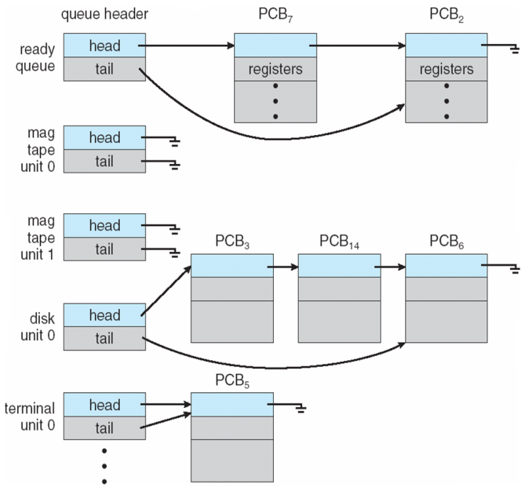
Figure: The ready queue and various I/O device queues.

A common representation of process scheduling is a queueing diagram, such as that in below Figure. Each rectangular box represents a queue. Two types of queues are present: the ready queue and a set of device queues. The circles represent the resources that serve the queues, and the arrows indicate the flow of processes in the system.

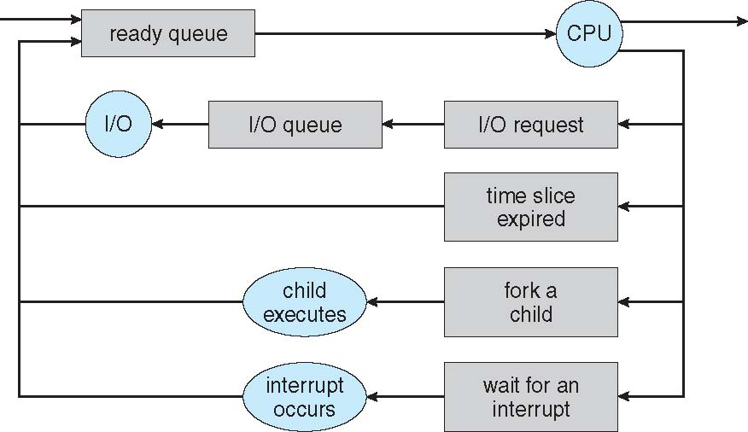

Figure: Queueing-diagram representation of process scheduling.

A new process is initially put in the ready queue. It waits there until it is selected for execution, or dispatched. Once the process is allocated the CPU and is executing, one of several events could occur:

- The process could issue an I/O request and then be placed in an I/O queue.
- The process could create a new child process and wait for the child’s termination.
- The process could be removed forcibly from the CPU, as a result of an interrupt, and be put back in the ready queue.
In the first two cases, the process eventually switches from the waiting state to the ready state and is then put back in the ready queue. A process continues this cycle until it terminates, at which time it is removed from all queues and has its PCB and resources deallocated.

Schedulers:

A process migrates among the various scheduling queues throughout its lifetime. The operating system must select, for scheduling purposes, processes from these queues in some fashion. The selection process is carried out by the appropriate scheduler.

Often, in a batch system, more processes are submitted than can be executed immediately. These processes are spooled to a mass-storage device (typically a disk), where they are kept for later execution. The long-term scheduler, or job scheduler, selects processes from this pool and loads them into memory for execution. The short-term scheduler, or CPU scheduler, selects from among the processes that are ready to execute and allocates the CPU to one of them.

The primary distinction between these two schedulers lies in frequency of execution. The short-term scheduler must select a new process for the CPU frequently. A process may execute for only a few milliseconds before waiting for an I/O request. Often, the short-term scheduler executes at least once every 100 milliseconds. Because of the short time between executions, the short-term scheduler must be fast. If it takes 10 milliseconds to decide to execute a process
for 100 milliseconds, then 10/(100 + 10) = 9 percent of the CPU is being used (wasted) simply for scheduling the work.

The long-term scheduler executes much less frequently; minutes may separate the creation of one new process and the next. The long-term scheduler controls the degree of multiprogramming (the number of processes in memory). If the degree of multiprogramming is stable, then the average rate of process creation must be equal to the average departure rate of processes leaving the system. Thus, the long-term scheduler may need to be invoked only when a process leaves the system. Because of the longer interval between executions, the long-term scheduler can afford to take more time to decide which process should be selected for execution.
It is important that the long-term scheduler make a careful selection. In general, most processes can be described as either I/O bound or CPU bound. An I/O-bound process is one that spends more of its time doing I/O than it spends doing computations. A CPU-bound process, in contrast, generates I/O requests infrequently, using more of its time doing computations. It is important that the long-term scheduler select a good process mix of I/O-bound and CPU-bound processes. If all processes are I/O bound, the ready queue will almost always be empty, and the short-term scheduler will have little to do.If all processes are CPU bound, the I/O waiting queue will almost always be empty, devices will go unused, and again the system will be unbalanced. The system with the best performance will thus have a combination of CPU-bound and I/O-bound processes.

On some systems, the long-term scheduler may be absent or minimal. For example, time-sharing systems such as UNIX and Microsoft Windows systems often have no long-term scheduler but simply put every new process in memory for the short-term scheduler. The stability of these systems depends either on a physical limitation (such as the number of available terminals)
or on the self-adjusting nature of human users. If performance declines to unacceptable levels on a multiuser system, some users will simply quit.
Some operating systems, such as time-sharing systems, may introduce an additional, intermediate level of scheduling. This medium-term scheduler is diagrammed in Figure 3.7. The key idea behind a medium-term scheduler is that sometimes it can be advantageous to remove a process from memory (and from active contention for the CPU) and thus reduce the degree of multiprogramming. Later, the process can be reintroduced into memory, and its
execution can be continued where it left off. This scheme is called swapping. The process is swapped out, and is later swapped in, by the medium-term scheduler. Swapping may be necessary to improve the process mix or because a change in memory requirements has overcommitted available memory, requiring memory to be freed up. Swapping is discussed in Chapter 8.

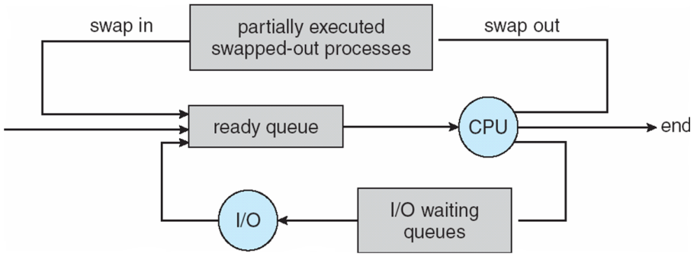
Figure: Addition of medium-term scheduling to the queueing diagram.

Context Switch:

Interrupts cause the operating system to change a CPU from its current task and to run a kernel routine. Such operations happen frequently on general-purpose systems. When an interrupt occurs, the system needs to save the current context of the process running on the CPU so that it can restore that context when its processing is done, essentially suspending the process and then resuming it. The context is represented in the PCB of the process. It includes the value of the CPU registers, the process state and memory-management information. Generically, we perform a state save of the current state of the CPU, be it in kernel or user mode, and then a state restore to resume operations.

Switching the CPU to another process requires performing a state save of the current process and a state restore of a different process. This task is known as a context switch. When a context switch occurs, the kernel saves the context of the old process in its PCB and loads the saved context of the new process scheduled to run. Context-switch time is pure overhead, because the system does no useful work while switching. Switching speed varies from machine to machine, depending on the memory speed, the number of registers that must be copied, and the existence of special instructions (such as a single instruction to load or store all registers). A typical speed is a few milliseconds.

Context-switch times are highly dependent on hardware support. For instance, some processors (such as the Sun UltraSPARC) provide multiple sets of registers. A context switch here simply requires changing the pointer to the current register set. Of course, if there are more active processes than there are register sets, the system resorts to copying register data to and from memory, as before. Also, the more complex the operating system, the greater the amount of work that must be done during a context switch.

***

Schedulers: (Simplified)
Schedulers are special system software which handles process scheduling in various ways. Their main task is to select the jobs to be submitted into the system and to decide which process to run. Schedulers are of three types −
- Long-Term Scheduler
- Short-Term Scheduler
- Medium-Term Scheduler

Long Term Scheduler
It is also called a job scheduler. A long-term scheduler determines which programs are admitted to the system for processing. It selects processes from the queue and loads them into memory for execution. Process loads into the memory for CPU scheduling.
The primary objective of the job scheduler is to provide a balanced mix of jobs, such as I/O bound and processor bound. It also controls the degree of multiprogramming. If the degree of multiprogramming is stable, then the average rate of process creation must be equal to the average departure rate of processes leaving the system.
On some systems, the long-term scheduler may not be available or minimal. Time-sharing operating systems have no long term scheduler. When a process changes the state from new to ready, then there is use of long-term scheduler.

Short Term Scheduler
It is also called as CPU scheduler. Its main objective is to increase system performance in accordance with the chosen set of criteria. It is the change of ready state to running state of the process. CPU scheduler selects a process among the processes that are ready to execute and allocates CPU to one of them.
Short-term schedulers, also known as dispatchers, make the decision of which process to execute next. Short-term schedulers are faster than long-term schedulers.

Medium Term Scheduler
Medium-term scheduling is a part of swapping. It removes the processes from the memory. It reduces the degree of multiprogramming. The medium-term scheduler is in-charge of handling the swapped out-processes.
A running process may become suspended if it makes an I/O request. A suspended process cannot make any progress towards completion. In this condition, to remove the process from memory and make space for other processes, the suspended process is moved to the secondary storage. This process is called swapping, and the process is said to be swapped out or rolled out. Swapping may be necessary to improve the process mix.

Comparison among Scheduler:

S.N. | Long-Term Scheduler | Short-Term Scheduler | Medium-Term Scheduler
1 | It is a job scheduler | It is a CPU scheduler | It is a process swapping scheduler.
2 | Speed is lesser than short term scheduler | Speed is fastest among other two | Speed is in between both short and long term scheduler.
3 | It controls the degree of multiprogramming | It provides lesser control over degree of multiprogramming | It reduces the degree of multiprogramming.
4 | It is almost absent or minimal in time sharing system | It is also minimal in time sharing system | It is a part of Time sharing systems.
5 | It selects processes from pool and loads them into memory for execution | It selects those processes which are ready to execute | It can re-introduce the process into memory and execution can be continued.

***
Operations on Processes:

The processes in most systems can execute concurrently, and they may be created and deleted dynamically. Thus, these systems must provide a mechanism for process creation and termination.

- Process creation
- Process termination

Process Creation

During the execution, a process may create several new processes. As mentioned earlier, the creating process is called a parent process, and the new processes are called the children of that process. Each of these new processes may in turn create other processes, forming a tree of processes.

Most operating systems (including UNIX, Linux, and Windows) identify processes according to a unique process identifier (or pid), which is typically an integer number. The pid provides a unique value for each process in the system, and it can be used as an index to access various attributes of a process within the kernel.

Figure: A tree of processes on a typical Linux system.

Above figure illustrates a typical process tree for the Linux operating system, showing the name of each process and its pid. (We use the term process rather loosely, as Linux prefers the term task instead.) The init process (which always has a pid of 1) serves as the root parent process for all user processes. Once the system has booted, the init process can also create various user processes, such as a web or print server, an ssh server, and the like.

In Figure, we see two children of init — kthreadd and sshd. The kthreadd process is responsible for creating additional processes that perform tasks on behalf of the kernel (in this situation, khelper and pdflush). The sshd process is responsible for managing clients that connect to the system by using ssh (which is short for secure shell).

The login process is responsible for managing clients that directly log onto the system. In this example, a client has logged on and is using the bash shell, which has been assigned pid 8416. Using the bashcommand-line interface, this user has created the process ps as well as the emacs editor.

On UNIX and Linux systems, we can obtain a listing of processes by using the ps command. For example, the command

ps –el

will list complete information for all processes currently active in the system. It is easy to construct a process tree similar to the one shown in Figure, by recursively tracing parent processes all the way to the initprocess.

In general, when a process creates a child process, that child process will need certain resources (CPU time, memory, files, I/O devices) to accomplish its task. A child process may be able to obtain its resources directly from the operating system, or it may be constrained to a subset of the resources of the parent process. The parent may have to partition its resources among its children, or it may be able to share some resources (such as memory or files) among several of its children. Restricting a child process to a subset of the parent’s resources prevents any process from overloading the system by creating too many child processes.

In addition to supplying various physical and logical resources, the parent process may pass along initialization data (input) to the child process. For example, consider a process whose function is to display the contents of a file —say, image.jpg—on the screen of a terminal. When the process is created, it will get, as an input from its parent process, the name of the file image.jpg. Using that file name, it will open the file and write the contents out. It may also get the name of the output device. Alternatively, some operating systems pass resources to child processes. On such a system, the new process may get two open files, image.jpg and the terminal device, and may simply transfer the datum between the two.

When a process creates a new process, two possibilities for execution exist:

- The parent continues to execute concurrently with its children.

- The parent waits until some or all of its children have terminated.

There are also two address-space possibilities for the new process:

- The child process is a duplicate of the parent process (it has the same program and data as the parent).
- The child process has a new program loaded into it.

To illustrate these differences, let’s first consider the UNIX operating system. In UNIX, as we’ve seen, each process is identified by its process identifier, which is a unique integer. A new process is created by the fork() system call. The new process consists of a copy of the address space of the original process. This mechanism allows the parent process to communicate easily with its child process. Both processes (the parent and the child) continue execution at the instruction after the fork(), with one difference: the return code for the fork() is zero for the new (child) process, whereas the (nonzero) process identifier of the child is returned to the parent.

After a fork() system call, one of the two processes typically uses the exec() system call to replace the process’s memory space with a new program. The exec() system call loads a binary file into memory (destroying the memory image of the program containing the exec() system call) and starts its execution. In this manner, the two processes are able to communicate and then go their separate ways. The parent can then create more children; or, if it has nothing else to do while the child runs, it can issue a wait() system call to move itself off the ready queue until the termination of the child. Because the call to exec() overlays the process’s address space with a new program, the call to exec() does not return control unless an error occurs.

Figure: Creating a separate process using the UNIX fork() system call.

The above c program illustrates the UNIX system calls previously described. We now have two different processes running copies of the same program. The only difference is that the value of pid (the process identifier) for the child process is zero, while that for the parent is an integer value greater than zero (in fact, it is the actual pid of the child process). The child process inherits privileges and scheduling attributes from the parent, as well certain resources, such as open files. The child process then overlays its address space with the UNIX command /bin/ls (used to get a directory listing) using the execlp() system call (execlp() is a version of the exec() system call). The parent waits for the child process to complete with the wait() system call. When the child process completes (by either implicitly or explicitly invoking exit()), the parent process resumes from the call to wait(), where it completes using the exit() system call. This is also illustrated in below figure

Figure: Process creation using the fork() system call.

There is nothing to prevent the child from not invoking exec() and instead continuing to execute as a copy of the parent process. In this scenario, the parent and child are concurrent processes running the same code instructions. Because the child is a copy of the parent, each process has its own copy of any data.

As an alternative example, we next consider process creation in Windows. Processes are created in the Windows API using the CreateProcess() function, which is similar to fork() in that a parent creates a new child process. However, whereas fork() has the child process inheriting the address space of its parent, CreateProcess() requires loading a specified program into the address space of the child process at process creation. Furthermore, whereas fork() is passed no parameters, CreateProcess() expects no fewer than ten parameters.

The Following C program illustrates the CreateProcess() function, which creates a child process that loads the application mspaint.exe. We opt for many of the default values of the ten parameters passed to CreateProcess().

The two parameters passed to the CreateProcess() function are instances of the STARTUPINFO and PROCESS INFORMATION structures. STARTUPINFO specifies many properties of the new process, such as window size and appearance and handles to standard input and output files. The PROCESS INFORMATION structure contains a handle and the identifiers to the newly created process and its thread. We invoke the ZeroMemory() function to allocate memory for each of these structures before proceeding with CreateProcess().

Figure: Creating a separate process using the Windows API.
The first two parameters passed to CreateProcess() are the application name and command-line parameters. If the application name is NULL (as it is in this case), the command-line parameter specifies the application to load. In this instance, we are loading the MicrosoftWindows mspaint.exe application. Beyond these two initial parameters, we use the default parameters for inheriting process and thread handles aswell as specifying that there will be no creation flags.We also use the parent’s existing environment block and starting directory. Last, we provide two pointers to the STARTUPINFO and PROCESS - INFORMATION structures created at the beginning of the program. Generally, the parent process waits for the child to complete by invoking the wait() system call. The equivalent of this in Windows is WaitForSingleObject(), which is passed a handle of the child process—pi.hProcess—and waits for this process to complete. Once the child process exits, control returns from the WaitForSingleObject() function in the parent process.

Process Termination

A process terminates when it finishes executing its final statement and asks the operating system to delete it by using the exit()system call. At that point, the process may return a status value (typically an integer) to its parent process (via the wait() system call). All the resources of the process—including physical and virtual memory, open files, and I/O buffers—are deallocated by the operating system.

Termination can occur in other circumstances as well. They are

A process can cause the termination of another process via an appropriate system call (for example, TerminateProcess()inWindows). Usually, such a system call can be invokedonly by the parent of the process that is to be terminated.

Otherwise, users could arbitrarily kill each other’s jobs. Note that a parentneeds to know the identities of its children if it is to terminate them. Thus, when one process creates a new process, the identity of the newly created process is passed to the parent.

A parent may terminate the execution of one of its children for a variety of reasons, such as these:

- The child has exceeded its usage of some of the resources that it has been allocated.
- The task assigned to the child is no longer required.
- The parent is exiting, and the operating system does not allow a child to continue if its parent terminates.

Some systems do not allow a child to exist if its parent has terminated. In such systems, if a process terminates (either normally or abnormally), then all its children must also be terminated. This phenomenon, referred to as cascading termination, is normally initiated by the operating system.

To illustrate process execution and termination, consider that, in Linux and UNIX systems, we can terminate a process by using the exit() system call, providing an exit status as a parameter:

/* exit with status 1 */
exit(1);

In fact, under normal termination, exit() may be called either directly (as shown above) or indirectly (by a return statement in main()).

A parent process may wait for the termination of a child process by using the wait() system call. The wait() system call is passed a parameter that allows the parent to obtain the exit status of the child. This system call also returns the process identifier of the terminated child so that the parent can tell which of its children has terminated:

pid t pid;
int status;
pid = wait(&status);

When a process terminates, its resources are deallocated by the operating system. However, its entry in the process table must remain there until the parent calls wait(), because the process table contains the process’s exit status.

A process that has terminated, butwhose parent has not yet called wait(), is known as a zombie process. All processes transition to this state when they terminate, but generally they exist as zombies only briefly. Once the parent calls wait(), the process identifier of the zombie process and its entry in the process table are released.

Now consider what would happen if a parent did not invoke wait() and instead terminated, thereby leaving its child processes as orphans. Linux and UNIX address this scenario by assigning the init process as the new parent to orphan processes. The init process periodically invokes wait(), thereby allowing the exit status of any orphaned process to be collected and releasing the orphan’s process identifier and process-table entry.

***

Interprocess Communication:

Processes executing concurrently in the operating system may be either independent processes or cooperating processes. A process is independent if it cannot affect or be affected by the other processes executing in the system. Any process that does not share data with any other process is independent. A process is cooperating if it can affect or be affected by the other processes executing in the system. Clearly, any process that shares data with other processes is a cooperating process.

There are several reasons for providing an environment that allows process cooperation:

• Information sharing. Since several users may be interested in the same piece of information (for instance, a shared file), we must provide an environment to allow concurrent access to such information.
• Computation speedup. Ifwewant a particular task to run faster,wemust break it into subtasks, each of which will be executing in parallel with the others. Notice that such a speedup can be achieved only if the computer has multiple processing cores.
• Modularity. We may want to construct the systemin a modular fashion, dividing the system functions into separate processes or threads, as we discussed in Chapter 2.
• Convenience. Even an individual user may work on many tasks at the same time. For instance, a user may be editing, listening to music, and compiling in parallel.

Cooperating processes require an interprocess communication (IPC) mechanism that will allow them to exchange data and information. There are two fundamental models of interprocess communication: shared memoryand message passing. In the shared-memorymodel, a region ofmemory that is shared by cooperating processes is established. Processes can then exchange information by reading and writing data to the shared region. In the message-passing model, communication takes place by means of messages exchanged between the cooperating processes. The two communications models are shown in following figure

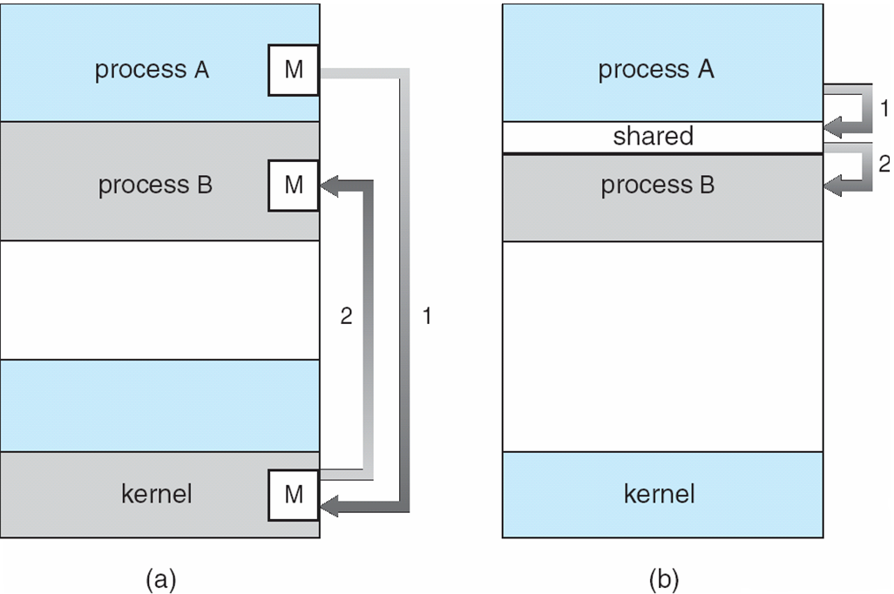

Figure:Communications models. (a) Message passing. (b) Shared memory.

Both of the models just mentioned are common in operating systems, and many systems implement both. Message passing is useful for exchanging smaller amounts of data, because no conflicts need be avoided. Message passing is also easier to implement in a distributed system than shared memory. (Although there are systems that provide distributed shared memory,wedo not consider them in this text.) Shared memory can be faster than message passing, since message-passing systems are typically implemented using system calls and thus require the more time-consuming task of kernel intervention. In shared-memory systems, system calls are required only to establish shared memory regions. Once shared memory is established, all accesses are treated as routine memory accesses, and no assistance from the kernel is required. Recent research on systems with several processing cores indicates that message passing provides better performance than shared memory on such systems. Shared memory suffers from cache coherency issues, which arise because shared data migrate among the several caches. As the number of processing cores on systems increases, it is possible that we will see message passing as the preferred mechanism for IPC.

Shared-Memory Systems

Interprocess communication using shared memory requires communicating processes to establish a region of shared memory. Typically, a shared-memory region resides in the address space of the process creating the shared-memory segment. Other processes that wish to communicate using this shared-memory segment must attach it to their address space. Recall that, normally, the operating system tries to prevent one process from accessing another process’s memory. Shared memory requires that two or more processes agree to remove this restriction. They can then exchange information by reading and writing data in the shared areas. The form of the data and the location are determined by these processes and are not under the operating system’s control. The processes are also responsible for ensuring that they are not writing to the same location simultaneously.

To illustrate the concept of cooperating processes, let’s consider the producer–consumer problem, which is a common paradigm for cooperating processes. A producer process produces information that is consumed by a consumer process. For example, a compiler may produce assembly code that is consumed by an assembler. The assembler, in turn, may produce object modules that are consumed by the loader. The producer–consumer problem also provides a useful metaphor for the client–server paradigm.We generally think of a server as a producer and a client as a consumer. For example, a web server produces (that is, provides) HTML files and images, which are consumed (that is, read) by the client web browser requesting the resource. One solution to the producer–consumer problem uses shared memory. To allow producer and consumer processes to run concurrently, we must have available a buffer of items that can be filled by the producer and emptied by the consumer. This buffer will reside in a region of memory that is shared by the producer and consumer processes. A producer can produce one item while the consumer is consuming another item. The producer and consumer must be synchronized, so that the consumer does not try to consume an item that has not yet been produced.

Two types of buffers can be used. The unbounded buffer places no practical limit on the size of the buffer. The consumer may have to wait for new items, but the producer can always produce new items. The bounded buffer assumes a fixed buffer size. In this case, the consumermustwait if the buffer is empty, and the producer must wait if the buffer is full. Let’s look more closely at how the bounded buffer illustrates interprocess communication using shared memory. The following variables reside in a region of memory shared by the producer and consumer processes:

The shared buffer is implemented as a circular array with two logical pointers: in and out. The variable in points to the next free position in the buffer; out points to the first full position in the buffer. The buffer is empty when in == out; the buffer is fullwhen ((in + 1) % BUFFER SIZE) == out.

The code for the producer process and the code for the consumer process is shown in Figures. The producer process has alocal variable next produced in which the new item to be produced is stored. The consumer process has a local variable next consumed in which the item to be consumed is stored.

Figure: The producer process using shared memory.

Figure: The consumer process using shared memory.

3.4.2 Message-Passing Systems

cooperating processes can communicate in a shared-memory environment. The scheme requires that these processes share a region ofmemory and that the code for accessing andmanipulating the shared memory be written explicitly by the application programmer. Another way to achieve the same effect is for the operating system to provide the means for cooperating processes to communicate with each other via a message-passingfacility.

Message passing provides a mechanism to allow processes to communicateand to synchronize their actions without sharing the same address space. It isparticularly useful in a distributed environment, where the communicatingprocesses may reside on different computers connected by a network. Forexample, an Internet chat program could be designed so that chat participantscommunicate with one another by exchanging messages.

Amessage-passing facility provides at least two operations:

- send(message)
- receive(message)

Messages sent by a process can be either fixed or variable in size. If only fixed-sized messages can be sent, the system-level implementation is straightforward. This restriction, however, makes the task of programming more difficult. Conversely, variable-sized messages require a more complex system level implementation, but the programming task becomes simpler. This is a common kind of tradeoff seen throughout operating-system design.

If processes P andQwant to communicate, theymust send messages to and receive messages from each other: a communication link must exist between them. This link can be implemented in a variety of ways.We are concerned here not with the link’s physical implementation (such as shared memory, hardware bus, or network, which are covered in Chapter 17) but rather with its logical implementation. Here are several methods for logically implementing a link and the send()/receive() operations:

• Direct or indirect communication
• Synchronous or asynchronous communication
• Automatic or explicit buffering
We look at issues related to each of these features next.

Naming

Processes that want to communicate must have a way to refer to each other. They can use either direct or indirect communication.

Under direct communication, each process that wants to communicate must explicitly name the recipient or sender of the communication. In this scheme, the send() and receive() primitives are defined as:

• send(P, message)—Send a message to process P.
• receive(Q, message)—Receive a message from process Q.

A communication link in this scheme has the following properties:

• A link is established automatically between every pair of processes that want to communicate. The processes need to know only each other’s identity to communicate.
• A link is associatedwith exactly two processes.
• Between each pair of processes, there exists exactly one link.

This scheme exhibits symmetry in addressing; that is, both the sender process and the receiver process must name the other to communicate. A variant of this scheme employs asymmetry in addressing. Here, only the sender names the recipient; the recipient is not required to name the sender. In this scheme, the send() and receive() primitives are defined as follows:

• send(P, message)—Send a message to process P.
• receive(id, message)—Receive a message from any process.

Thevariable id is set to the name of the process with which communication has taken place.

The disadvantage in both of these schemes (symmetric and asymmetric)is the limited modularity of the resulting process definitions. Changing the identifier of a process may necessitate examining all other process definitions. All references to the old identifier must be found, so that they can be modified to the new identifier.

In indirect communication, themessages are sent to and received from mailboxes, or ports.Amailbox canbe viewedabstractly as anobject intowhich messages can be placed by processes and fromwhichmessages can be removed. Each mailbox has a unique identification. For example, POSIX message queues use an integer value to identify a mailbox. A process can communicate with another process via a number of different mailboxes, but two processes can communicate only if they have a shared mailbox. The send() and receive() primitives are defined as follows:

• send(A, message)—Send a message to mailbox A.
• receive(A, message)—Receive a message from mailbox A.

In this scheme, a communication link has the following properties:

• A link is established between a pair of processes only if both members of the pair have a shared mailbox.
• A linkmay be associated withmore than two processes.
• Between each pair of communicating processes, a number of different links may exist, with each link corresponding to one mailbox.

Now suppose that processes P1, P2, and P3 all share mailbox A. Process P1 sends a message to A, while both P2 and P3 execute a receive() from A. Which process will receive the message sent by P1? The answer depends on which of the following methods we choose:

• Allow a link to be associated with two processes at most.
• Allow at most one process at a time to execute a receive() operation.
• Allow the system to select arbitrarily which process will receive the message (that is, either P2 or P3, butnotboth,will receive themessage).

The system may define an algorithm for selecting which process will receive the message (for example, round robin, where processes take turns receiving messages). The system may identify the receiver to the sender.

A mailboxmay be owned either by a process or by the operating system. If the mailbox is owned by a process (that is, the mailbox is part of the address space of the process), then we distinguish between the owner (which can only receive messages through this mailbox) and the user (which can only send messages to the mailbox). Since each mailbox has a unique owner, there can be no confusion about which process should receive a message sent to this mailbox. When a process that owns a mailbox terminates, the mailboxdisappears. Any process that subsequently sends a message to this mailbox must be notified that the mailbox no longer exists. In contrast, a mailbox that is owned by the operating system has an existence of its own. It is independent and is not attached to any particular process. The operating system then must provide a mechanism that allows a process to do the following:

• Create a new mailbox.
• Send and receive messages through the mailbox.
• Delete a mailbox.

The process that creates a new mailbox is that mailbox’s owner by default.Initially, the owner is the only process that can receive messages through this mailbox. However, the ownership and receiving privilege may be passed to other processes through appropriate system calls. Of course, this provision could result in multiple receivers for each mailbox.
Synchronization

Communication between processes takes place through calls to send() and receive() primitives. There are different design options for implementing each primitive. Message passing may be either blocking or nonblocking— also known as synchronous and asynchronous. (Throughout this text, you will encounter the concepts of synchronous and asynchronous behavior in relation to various operating-system algorithms.)

• Blocking send. The sending process is blocked until the message is received by the receiving process or by the mailbox.
• Nonblocking send. The sending process sends the message and resumes operation.
• Blocking receive. The receiver blocks until amessage is available.
• Nonblocking receive. The receiver retrieves either a valid message or a null.

Different combinations of send() and receive() are possible.When both send() and receive() are blocking, we have a rendezvous between the sender and the receiver. The solution to the producer–consumer problem becomes trivial when we use blocking send() and receive() statements. The producer merely invokes the blocking send() call and waits until the message is delivered to either the receiver or the mailbox. Likewise, when the consumer invokes receive(), it blocks until a message is available.

Buffering

Whether communication is direct or indirect, messages exchanged by communicating processes reside in a temporary queue. Basically, such queues can be
implemented in three ways:

message next produced;
while (true) {
/* produce an item in next produced */

send(next produced);
}

Figure 3.15 The producer process using message passing.

• Zero capacity. The queue has a maximum length of zero; thus, the link cannot have any messageswaiting in it. In this case, the sender must block until the recipient receives the message.
• Bounded capacity. The queue has finite length n; thus, at most n messages can reside in it. If the queue is not full when a new message is sent, the message is placed in the queue (either the message is copied or a pointer to the message is kept), and the sender can continue execution without waiting. The link’s capacity is finite, however. If the link is full, the sender must block until space is available in the queue.
• Unbounded capacity. The queue’s length is potentially infinite; thus, any number of messages can wait in it. The sender never blocks. The zero-capacity case is sometimes referred to as a message system with no buffering. The other cases are referred to as systems with automatic buffering.

***
Examples of IPC Systems:

An Example: POSIX Shared Memory:
Several IPC mechanisms are available for POSIX systems, including shared memory and message passing. Here, we explore the POSIX API for shared memory.
POSIX shared memory is organized using memory-mapped files, which associate the region of shared memory with a file. A process must first create a shared-memory object using the shm open() system call, as follows:
shm fd = shm open(name, O_CREAT | O_RDRW, 0666);
The first parameter specifies the name of the shared-memory object. Processes that wish to access this shared memory must refer to the object by this name. The subsequent parameters specify that the shared-memory object is to be created if it does not yet exist (O_CREAT) and that the object is open for reading and writing (O_RDRW). The last parameter establishes the directory permissions of the shared-memory object. A successful call to shm_open() returns an integer file descriptor for the shared-memory object.
Once the object is established, the ftruncate() function is used to configure the size of the object in bytes. The call
ftruncate(shm_fd, 4096);
sets the size of the object to 4,096 bytes.
Finally, the mmap() function establishes a memory-mapped file containing the shared-memory object. It also returns a pointer to the memory-mapped file that is used for accessing the shared-memory object.
The producer–consumer model in implementing shared memory. The producer establishes a shared memory object and writes to shared memory, and the consumer reads from shared memory.
The producer, creates a shared-memory object named OS and writes the infamous string "Hello World!" to shared memory. The program memory-maps a shared-memory object of the specified size and allows writing to the object. (Obviously, only writing is necessary for the producer.) The flag MAP SHARED specifies that changes to the shared-memory object will be visible to all processes sharing the object. Notice that we write to the shared-memory object by calling the sprintf() function and writing the formatted string to the pointer ptr. After each write, we must increment the pointer by the number of bytes written.

The consumer process,reads and outputs the contents of the shared memory. The consumer also invokes the shm unlink() function, which removes the shared-memory segment after the consumer has accessed it.

***

An Example: Mach
As an example of message passing, we next consider the Mach operatingsystem.The Mach kernel supports the creation and destructionof multiple tasks, which are similar to processes but have multiple threadsof control and fewer associated resources. Most communication in Mach—including all intertask information—is carried out by messages. Messages aresent to and received from mailboxes, called ports in Mach.
Even system calls are made by messages. When a task is created, twospecial mailboxes—the Kernel mailbox and the Notify mailbox—are alsocreated. The kernel uses the Kernel mailbox to communicate with the task andsends notification of event occurrences to the Notify port. Only three systemcalls are needed for message transfer. The msg send() call sends a messageto a mailbox. A message is received via msg receive(). Remote procedurecalls (RPCs) are executed via msg rpc(), which sends amessage andwaits forexactly one return message from the sender. In this way, the RPC models atypical subroutine procedure call but can work between systems—hence theterm remote.
The port_allocate() system call creates a new mailbox and allocatesspace for its queue of messages. The maximum size of the message queuedefaults to eight messages. The task that creates the mailbox is that mailbox’sowner. The owner is also allowed to receive from the mailbox. Only one taskat a time can either own or receive from a mailbox, but these rights can be sentto other tasks.
The mailbox’s message queue is initially empty. As messages are sent tothe mailbox, the messages are copied into the mailbox. All messages have thesame priority. Mach guarantees that multiple messages from the same senderare queued in first-in, first-out (FIFO) order but does not guarantee an absoluteordering. For instance, messages fromtwo sendersmay be queued in any order.
The messages themselves consist of a fixed-length header followed by avariable-length data portion. The header indicates the length of the messageand includes two mailbox names. One mailbox name specifies the mailboxreply, so the mailbox name of the sender is passed on to the receiving task,which can use it as a “return address.”
The variable part of a message is a list of typed data items. Each entryin the list has a type, size, and value. The type of the objects specified in themessage is important, since objects defined by the operating system—such asownership or receive access rights, task states, and memory segments—maybe sent in messages.
The send and receive operations themselves are flexible. For instance,whena message is sent to a mailbox, the mailbox may be full. If the mailbox is notfull, the message is copied to the mailbox, and the sending thread continues. Ifthe mailbox is full, the sending thread has four options:
1. Wait indefinitely until there is room in the mailbox.
2. Wait at most n milliseconds.
3. Do not wait at all but rather return immediately.
4. Temporarily cache a message. Here, a message is given to the operatingsystem to keep, even though the mailbox to which that message is beingsent is full. When the message can be put in the mailbox, a message is sentback to the sender. Only one message to a full mailbox can be pending atany time for a given sending thread.
The final option is meant for server tasks, such as a line-printer driver. Afterfinishing a request, such tasks may need to send a one-time reply to the taskthat requested service, but they must also continue with other service requests,even if the reply mailbox for a client is full.
The receive operation must specify the mailbox or mailbox set fromwhich amessage is to be received.Amailbox set is a collection of mailboxes, as declaredby the task, which can be grouped together and treated as one mailbox for thepurposes of the task. Threads in a task can receive only from a mailbox ormailbox set for which the task has receive access. A port status() systemcall returns the number of messages in a given mailbox. The receive operationattempts to receive from (1) any mailbox in a mailbox set or (2) a specific(named) mailbox. If no message is waiting to be received, the receiving threadcan either wait at most n milliseconds or not wait at all.
The major problem with message systems has generally been poorperformance caused by double copying of messages: the message is copiedfirst from the sender to the mailbox and then from the mailbox to the receiver.The Mach message system attempts to avoid double-copy operations by usingvirtual-memory-management techniques. Essentially, Mach mapsthe address space containing the sender’s message into the receiver’s addressspace. The message itself is never actually copied. This message-managementtechnique provides a large performance boost but works for only intrasystem messages.

***

An Example: Windows

TheWindows operating system is an example of modern design that employsmodularity to increase functionality and decrease the time needed to implementnew features. Windows provides support for multiple operating environments,or subsystems. Application programs communicate with thesesubsystems via a message-passing mechanism. Thus, application programscan be considered clients of a subsystem server.

The message-passing facility in Windows is called the advanced localprocedure call (ALPC) facility. It is used for communication between twoprocesses on the same machine. It is similar to the standard remote procedurecall (RPC) mechanism that is widely used, but it is optimized for and specificto Windows. (Remote procedure calls are covered in detail in Section 3.6.2.)Like Mach,Windows uses a port object to establish and maintain a connectionbetween two processes.

Windows uses two types of ports:
- connection ports
- communication ports.

Server processes publish connection-port objects that are visible to allprocesses. When a client wants services from a subsystem, it opens a handle tothe server’s connection-port object and sends a connection request to that port.The server then creates a channel and returns a handle to the client. The channelconsists of a pair of private communication ports: one for client—servermessages, the other for server—client messages. Additionally, communicationchannels support a callback mechanism that allows the client and server toaccept requests when they would normally be expecting a reply.When an ALPC channel is created, one of three message-passing techniques
is chosen:
1. For small messages (up to 256 bytes), the port’s message queue is usedas intermediate storage, and the messages are copied from one process tothe other.
2. Larger messages must be passed through a section object, which is aregion of shared memory associated with the channel.
3. When the amount of data is too large to fit into a section object, an API isavailable that allows server processes to read and write directly into theaddress space of a client.

The client has to decide when it sets up the channel whether it will needto send a large message. If the client determines that it does want to sendlarge messages, it asks for a section object to be created. Similarly, if the serverdecides that replies will be large, it creates a section object. So that the sectionobject can be used, a small message is sent that contains a pointer and sizeinformation about the section object. This method is more complicated thanthe first method listed above, but it avoids data copying. The structure ofadvanced local procedure calls in Windows is shown in Figure 3.19.It is important to note that the ALPC facility in Windows is not part of theWindows API and hence is not visible to the application programmer. Rather,applications using the Windows API invoke standard remote procedure calls.When the RPC is being invoked on a process on the same system, the RPC ishandled indirectly through an ALPC. procedure call. Additionally,many kernel
services use ALPC to communicate with client processes.

References:

Abraham Silberschatz, Greg Gagne, and Peter Baer Galvin, "Operating System Concepts, Ninth Edition "

